**IMDB Movies Team Project:**

Group 1:

* Amey Parange
* Ashwini Khedkar
* Asawari Kadam
* Neha Bhutkar

**Introduction**

Data Profiling and Analysis Report (Alteryx)

2.1 Data Profiling

- Overview of Data Profiling

- Purpose and Significance

- Tools and Techniques Used (Alteryx)

2.2 Analysis Report (Inference)

- Exploratory Data Analysis (EDA)

- Key Findings and Insights

- Data Quality Assessment

**Mapping Document**

3.1 Source and Target Mapping

- Overview of Mapping

- Template Explanation

- Source Systems

- Target Systems

3.2 Data Flow Diagrams

- Visual Representation of Data Flows

- Transformation Processes

- Connection Points

**Data Modeling**

4.1 Movie Titles Dimension Table

- Type 2 Implementation

- Attributes and Hierarchies

- Historical Data Handling

4.2 Entity-Relationship Diagram (ERD)

- Overview of ERD

- Relationships and Cardinalities

- Entity Descriptions

**ETL Mappings Using Talend**

5.1 Talend Introduction

- Overview of Talend

- Purpose in ETL Process

5.2 Metadata Based Connections

- Explanation of Metadata Connections

- Implementation in Talend

5.3 Contexts in Talend

- Introduction to Contexts

- Utilization in ETL Jobs

5.4 Environment Setup

- Configuration and Setup Steps

- Dependencies and Requirements

**Data Profiling using Alteryx:**

**Worflow Screenshots : Up and running :**

For Table **imdb_name_basics**

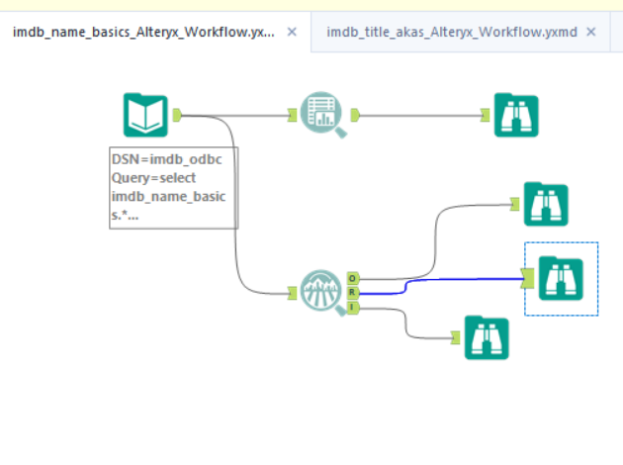

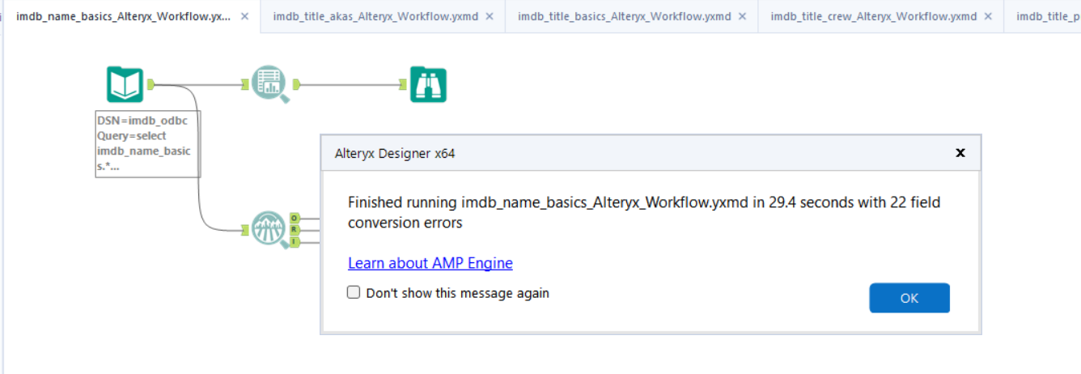

|  |  |  |  |  |  |  |
| --- | --- | --- | --- | --- | --- | --- |
| Name | Datatype | % missing | Unique values | Observation | Min Value | Max Value |
| birthYear | String | 0% | 376 | Some values of this field have a small number of value counts. If Appropriate, consider combining some value levels together. | 1 | 1,208,042 |
| deathYear | String | 0% | 322 | Some values of this field have a small number of value counts. If Appropriate, consider combining some value levels together. | 1 | 1,358,373 |
| knownForTitles | String | 0% | 1,172,487 | Some values of this field have a small number of value counts. If Appropriate, consider combining some value levels together. | 1 | 76,778 |
| nconst | String | 0% | 1,454,602 | Some values of this field have a small number of value counts. If Appropriate, consider combining some value levels together. | 1 | 1 |
| primaryName | String | 0% | 1,349,758 | Some values of this field have a small number of value counts. If Appropriate, consider combining some value levels together. | 1 | 36 |
| primaryProfession | String | 0% | 12162 | Some values of this field have a small number of value counts. If Appropriate, consider combining some value levels together | 1 | 248,050 |
| DI_Create_DT | String | 0% | 76 |  |  |  |

For Table **imdb_name_akas**

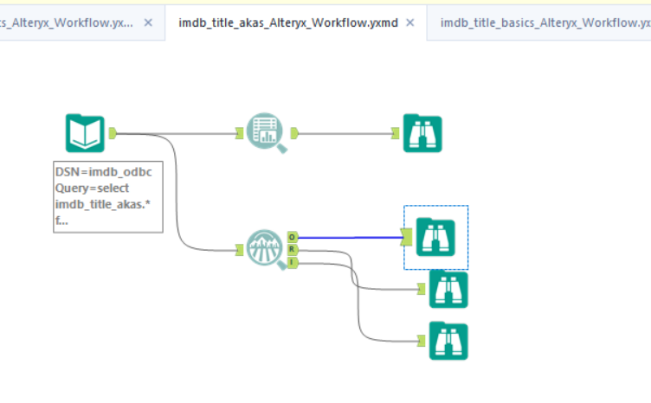

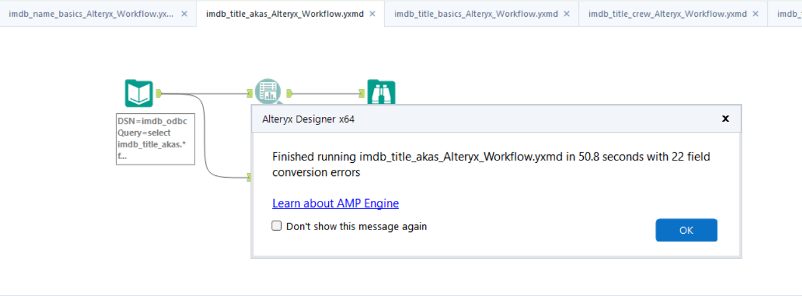

|  |  |  |  |  |  |  |
| --- | --- | --- | --- | --- | --- | --- |
| Name | Datatype | % missing | Unique values | Observation | Min Value | Max Value |
| Ordering | Numeric | 0% | 149 |  | 1 |  |
| Language | String | 0% | 101 | Some values of this field have a small number of value counts. If Appropriate, consider combining some value levels together. | 1 | 2177430 |
| Attributes | String | 0% | 130 | Some values of this field have a small number of value counts. If Appropriate, consider combining some value levels together. | 1 | 2486126 |
| title | String | 0% | 1497026 | Some values of this field have a small number of value counts. If Appropriate, consider combining some value levels together. | 1 | 189 |
| types | String | 0% | 24 | Some values of this field have a small number of value counts. If Appropriate, consider combining some value levels together. | 1 | 1468665 |
| region | String | 0% | 235 | Some values of this field have a small number of value counts. If Appropriate, consider combining some value levels together. | 1 | 531054 |
| titleId | String | 0% | 592887 | Some values of this field have a small number of value counts. If Appropriate, consider combining some value levels together. |  | 149 |
| isOriginalTitle | String | 0% | 3 | Some values of this field have a small number of value counts. If Appropriate, consider combining some value levels together. | 37 | 2121643 |
| DI_Create_DT | Date Time |  | 126 | Some values of this field have a small number of value counts. If Appropriate, consider combining some value levels together. |  |  |

**imdb_title_basics**

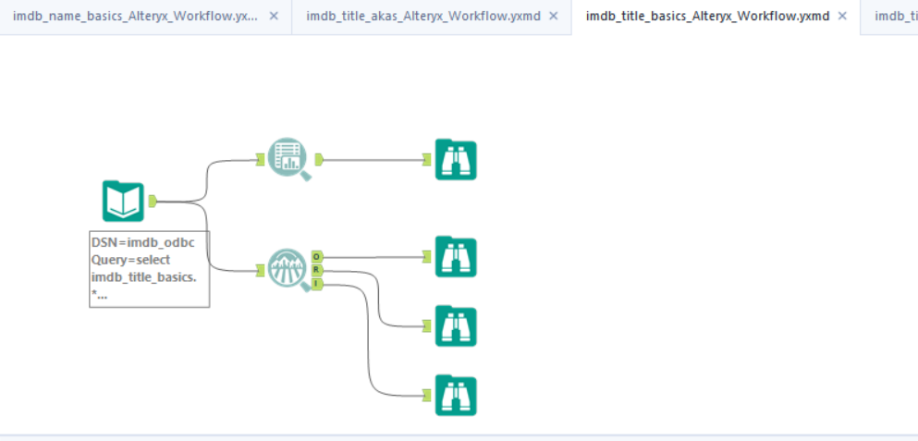

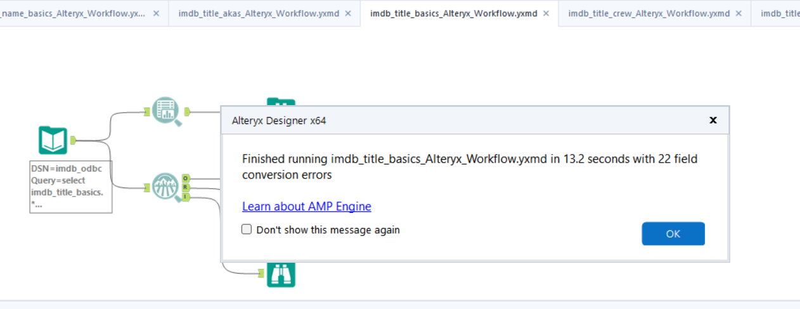

|  |  |  |  |  |  |  |
| --- | --- | --- | --- | --- | --- | --- |
|  | Datatype | % missing | Unique values | Observation | Min Value | Max Value |
| isAdult | Numeric | 0% | 2 | This field has a small number of unique values, and appears to be a categorical field. Consider changing the field data type to "string". | 1 |  |
| DI_Create_DT | Date | 0% | 40 | Some values of this field have a small number of value counts. If Appropriate, consider combining some value levels together. |  |  |
| genres | String | 0% | 1,459 | Some values of this field have a small number of value counts. If Appropriate, consider combining some value levels together. | 1 | 112,401 |
| runtimeMinutes | String | 0% | 489 | Some values of this field have a small number of value counts. If Appropriate, consider combining some value levels together. | 1 | 225,251 |
| primaryTitle | String | 0% | 526,041 | Some values of this field have a small number of value counts. If Appropriate, consider combining some value levels together. | 1 | 52 |
| tconst | String | 0% | 607,423 | Some values of this field have a small number of value counts. If Appropriate, consider combining some value levels together. | 1 | 1 |
| originalTitle | String | 0% | 537,134 | Some values of this field have a small number of value counts. If Appropriate, consider combining some value levels together. | 1 | 48 |
| startYear | String | 0% | 135 | Some values of this field have a small number of value counts. If Appropriate, consider combining some value levels together. | 1 | 79,022 |
| endYear | String | 0% | 1 | Some values of this field have a small number of value counts. If Appropriate, consider combining some value levels together. | 607,423 | 607,423 |
| titleType | String | 0% | 1 |  | 607,423 | 607,423 |

**imdb_title_crew**

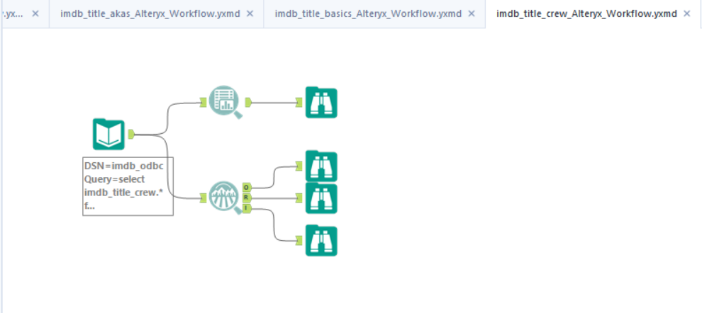

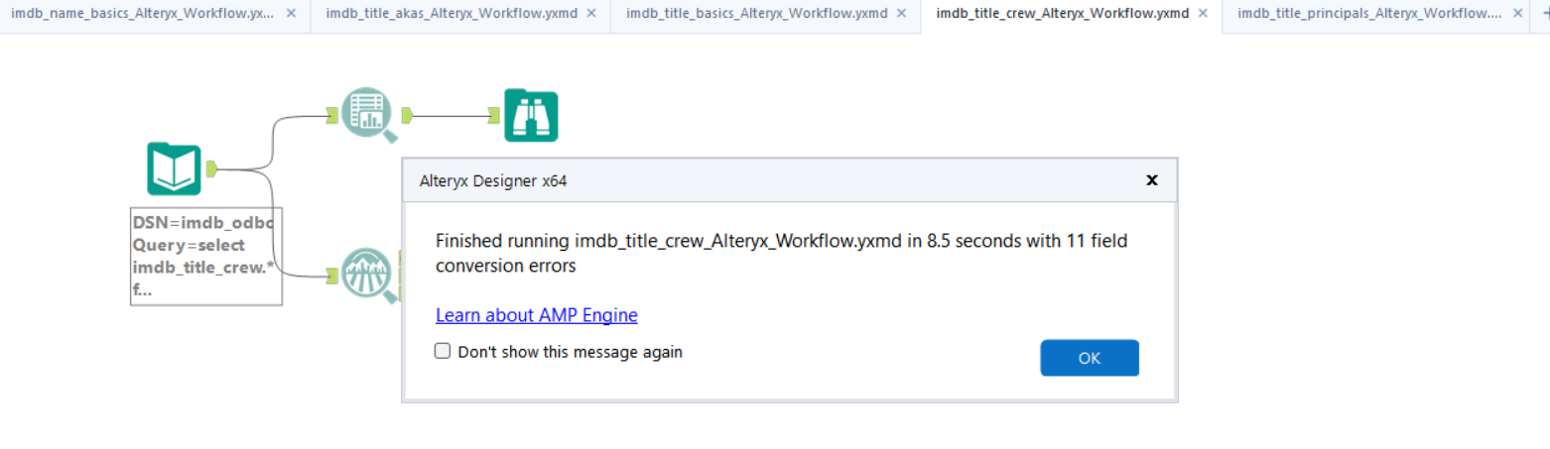

|  |  |  |  |  |  |  |  |
| --- | --- | --- | --- | --- | --- | --- | --- |
| Name | Datatype | % missing | Unique values | Null values | Observation | Min Value | Max Value |
| DI_Create_DT | Date | 0% | 26 |  | Some values of this field have a small number of value counts. If Appropriate, consider combining some value levels together. |  |  |
| directors | String | 0% | 320,758 |  | Some values of this field have a small number of value counts. If Appropriate, consider combining some value levels together. | 1 | 63,673 |
| writers | String | 0% | 607,423 |  | Some values of this field have a small number of value counts. If Appropriate, consider combining some value levels together. | 1 | 48,775 |
| tconst | String | 0% |  |  | Some values of this field have a small number of value counts. If Appropriate, consider combining some value levels together. | 1 | 1 |

**imdb_title_principals**

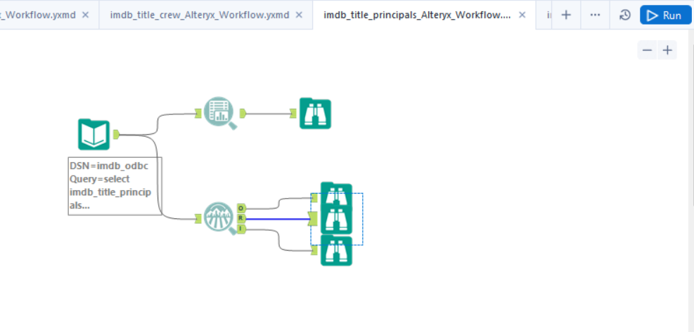

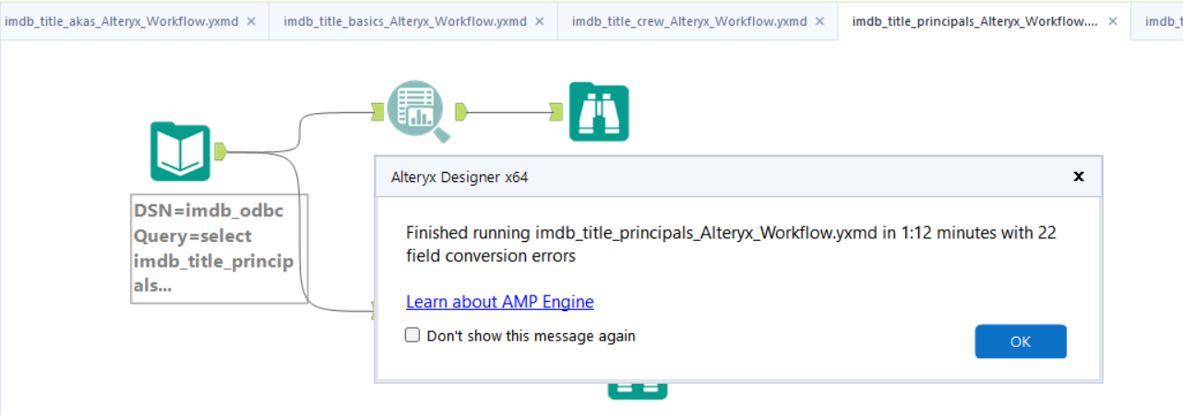

|  |  |  |  |  |  |  |  |
| --- | --- | --- | --- | --- | --- | --- | --- |
| Name | Datatype | % missing | Unique values | Null values | Observation | Min Value | Max Value |
| ordering | Numeric | 0% | 10 |  | This field has a small number of unique values, and appears to be a categorical field. Consider changing the field data type to "string". | 1.000 | 10.000 |
| DI_Create_DT | Date | 0% | 152 |  | Some values of this field have a small number of value counts. If Appropriate, consider combining some value levels together. |  |  |
| category | String | 0% | 12 |  | Some values of this field have a small number of value counts. If Appropriate, consider combining some value levels together. | 60 | 1,176,368 |
| job | String | 0% | 19,815 |  | Some values of this field have a small number of value counts. If Appropriate, consider combining some value levels together. | 1 | 3,550,474 |
| nconst | String | 0% | 1,450,993 |  | Some values of this field have a small number of value counts. If Appropriate, consider combining some value levels together. | 1 | 1,009 |
| characters | String | 0% | 703,924 |  |  | 1 | 2,813,735 |
| tconst | String | 0% | 591,300 |  |  | 1 | 10 |

**imdb_title_ratings**

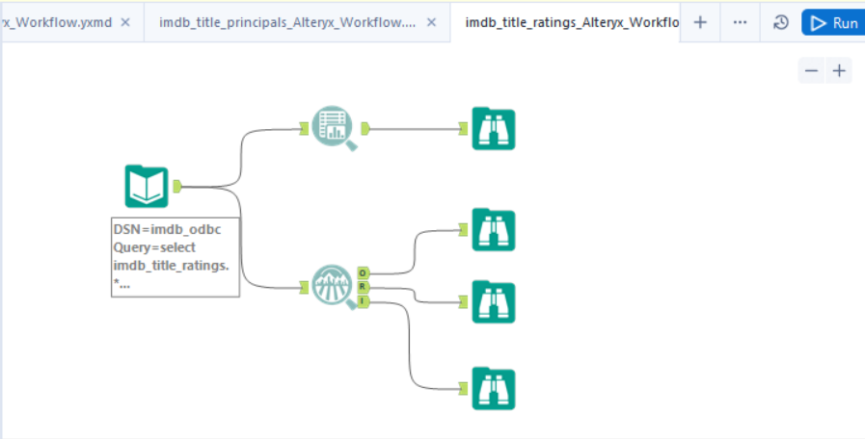

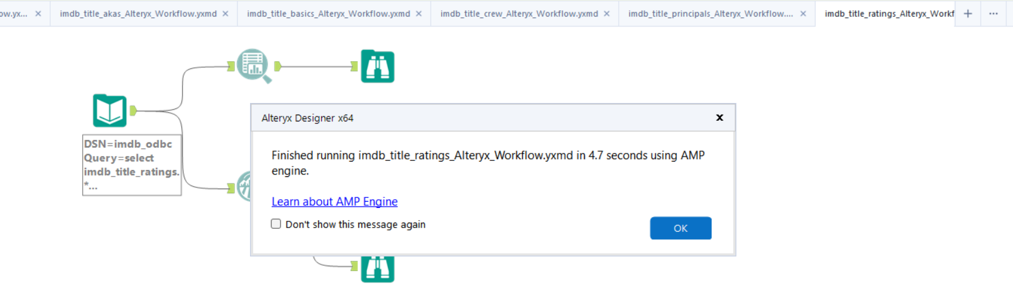

|  |  |  |  |  |  |  |
| --- | --- | --- | --- | --- | --- | --- |
| Name | Datatype | % missing | Unique values | Observation | Min Value | Max Value |
| DI_Create_DT | Date | 0% | 10 | This field has a small number of unique values, and appears to be a categorical field. Consider changing the field data type to "string". |  |  |
| averageRating | Numeric | 0% | 91 | Some values of this field have a small number of value counts. If Appropriate, consider combining some value levels together. | 1 | 10 |
| numVotes | Numeric | 0% | 16,972 | Some values of this field have a small number of value counts. If Appropriate, consider combining some value levels together. | 5 | 2,572,812 |
| tconst | String | 0% | 277,171 | Some values of this field have a small number of value counts. If Appropriate, consider combining some value levels together. | 1 | 1 |

**tsv file Data Profiling:**

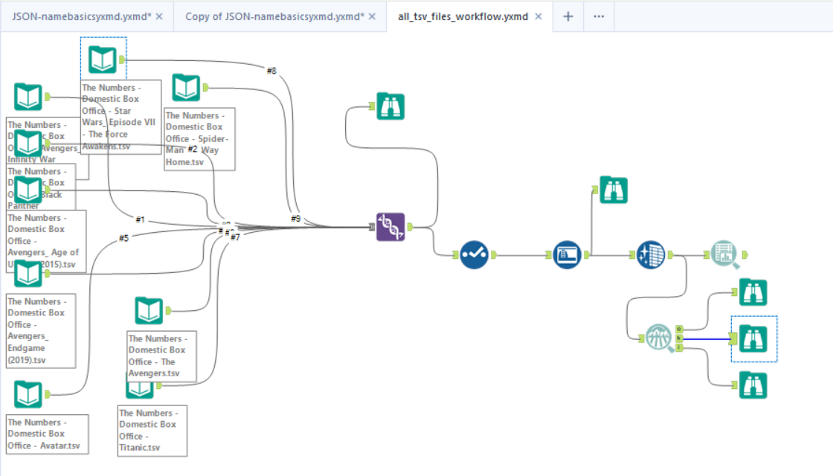

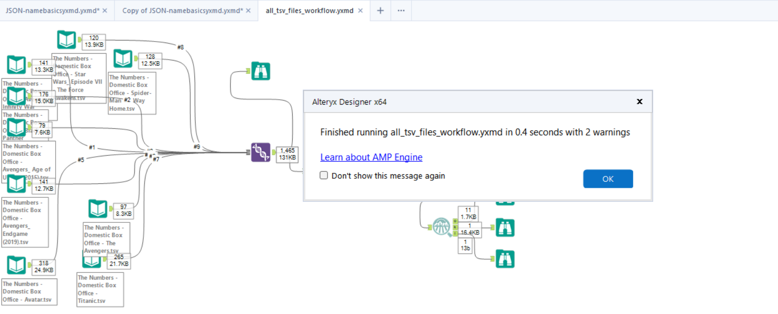

|  |  |  |  |  |  |  |
| --- | --- | --- | --- | --- | --- | --- |
| Name | Datatype | % missing | Unique values | Observation | Min Value | Max Value |
| Total Gross | String | 0% | 1,465 | Some values of this field have a small number of value counts. If Appropriate, consider combining some value levels together. | 1 | 1 |
| Rank | String | 0% | 20 | Some values of this field have a small number of value counts. If Appropriate, consider combining some value levels together. | 1 | 473 |
| %YD | String | 1.5% | 255 | Some values of this field have a small number of value counts. If Appropriate, consider combining some value levels together. | 1 | 24 |
| Date | Date | 0% | 1,323 | Some values of this field have a small number of value counts. If Appropriate, consider combining some value levels together. | 1 | 2 |
| Theaters | String | 0% | 191 | Some values of this field have a small number of value counts. If Appropriate, consider combining some value levels together. | 1 | 28 |
| Per Theater | String | 0.3% | 968 | Some values of this field have a small number of value counts. If Appropriate, consider combining some value levels together. | 1 | 7 |
| Days | String | 0.2% | 399 | Some values of this field have a small number of value counts. If Appropriate, consider combining some value levels together. | 1 | 9 |
| Gross | String | 0.0% | 1,462 | Some values of this field have a small number of value counts. If Appropriate, consider combining some value levels together. | 1 | 2 |
| %LW | String | 7.0% | 179 | Some values of this field have a small number of value counts. If Appropriate, consider combining some value levels together. | 1 | 102 |
| title | String | 0.0% | 9 |  | 79 | 318 |
| tconst | String | 8.7% | 9 |  | 79 | 318 |

**JSON Files Data Profiling:**

**name_basics**

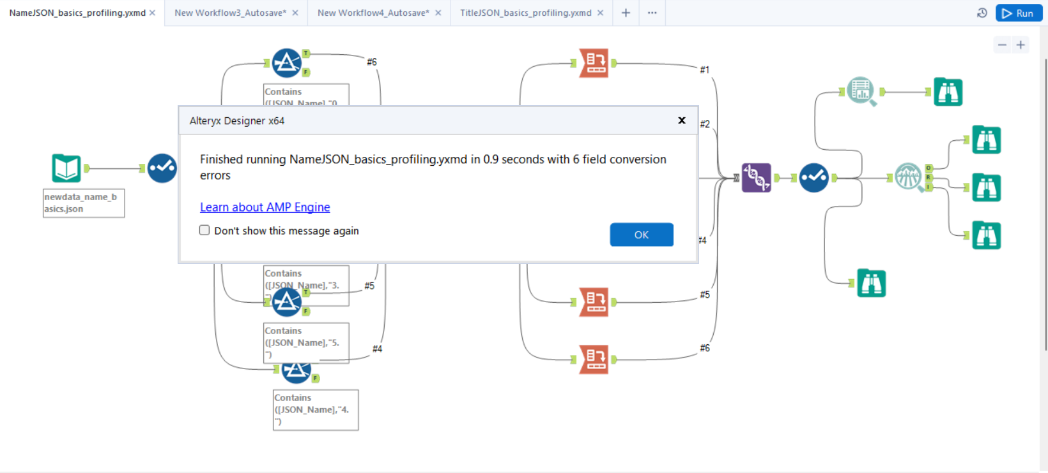

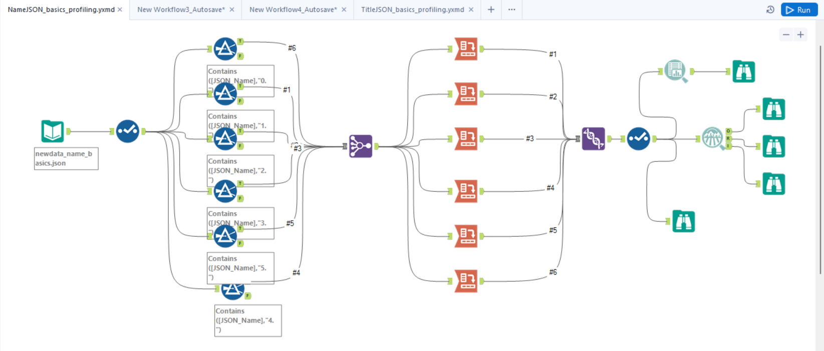

|  |  |  |  |  |  |  |
| --- | --- | --- | --- | --- | --- | --- |
| Name | Datatype | % missing | Unique values | Observation | Min Value | Max Value |
| BIrth Year | Numeric | 0% | 6 | This field has a small number of unique values, and appears to be a categorical field. Consider changing the field data type to "string". | 1,965 | 1,984 |
| Death Year | Numeric | 100% | 1 | This field has over 10% missing values. Consider imputing these values. This field has a small number of unique values, and appears to be a categorical field. Consider changing the field data type to "string". |  |  |
| Known For Titles | String | 0% | 6 | This field has a small number of unique values, and appears to be a categorical field. Consider changing the field data type to "string". | 1 | 1 |
| Primary Name | String | 0% | 6 |  | 1 | 1 |
| Primary Profession | String | 0% | 2 |  | 1 | 5 |
| Nconst | String | 0.0% | 6 |  | 1 | 1 |

**newdata_title_basics**

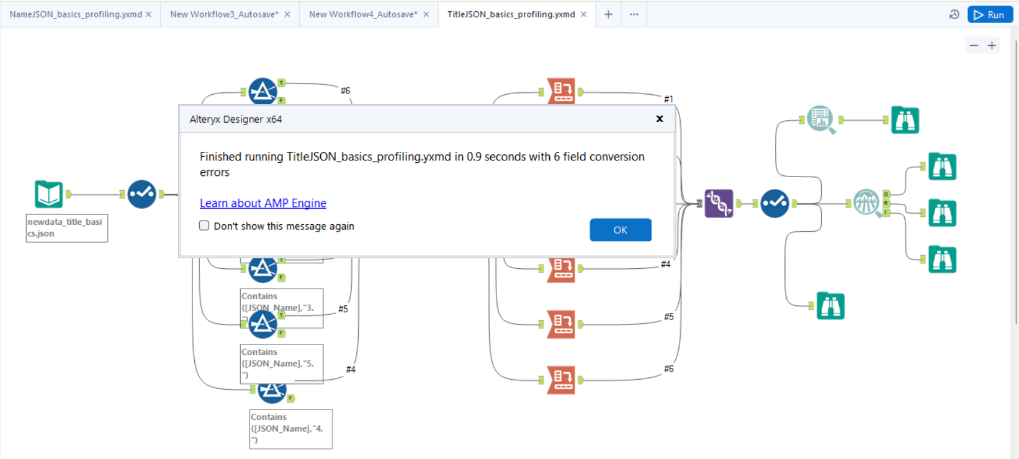

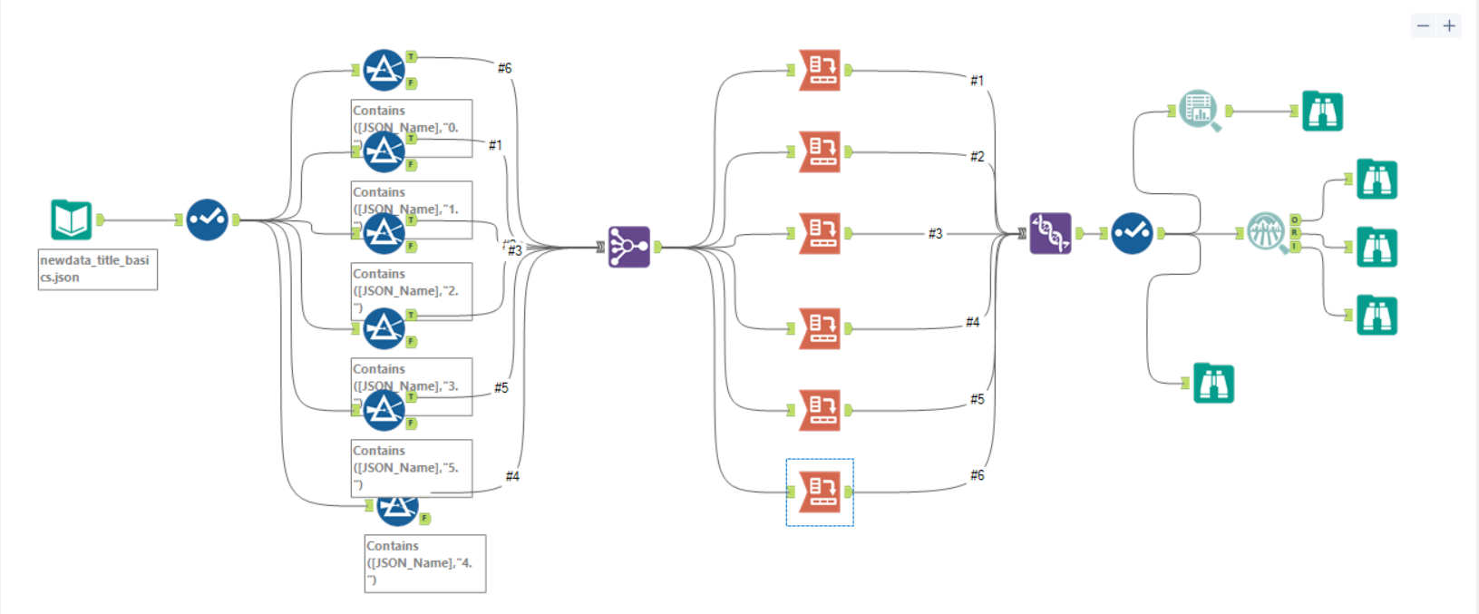

|  |  |  |  |  |  |  |
| --- | --- | --- | --- | --- | --- | --- |
| Name | Datatype | % missing | Unique values | Observation | Min Value | Max Value |
| endYear | Numeric | 100.0% | 1 | This field has over 10% missing values. Consider imputing these values. This field has a small number of unique values, and appears to be a categorical field. Consider changing the field data type to "string". |  |  |
| runtimeMinutes | Numeric | 0% | 6 | This field has a small number of unique values, and appears to be a categorical field. Consider changing the field data type to "string". | 134 | 194 |
| startYear | Numeric | 0% | 6 | This field has a small number of unique values, and appears to be a categorical field. Consider changing the field data type to "string". | 1,997 | 2,021 |
| titleType | String | 0% | 1 |  | 6 | 6 |
| primaryTitle | String | 0% | 6 |  | 1 | 1 |
| isAdult | String | 0.0% | 1 |  | 6 | 6 |
| genres | String | 0.0% | 3 |  | 1 | 3 |
| tconst | String | 0.0% | 6 |  | 1 | 1 |
| originalTitle | String | 0.0% | 6 |  | 1 | 1 |

**Talend Worflows : Staging**

**Staging:**

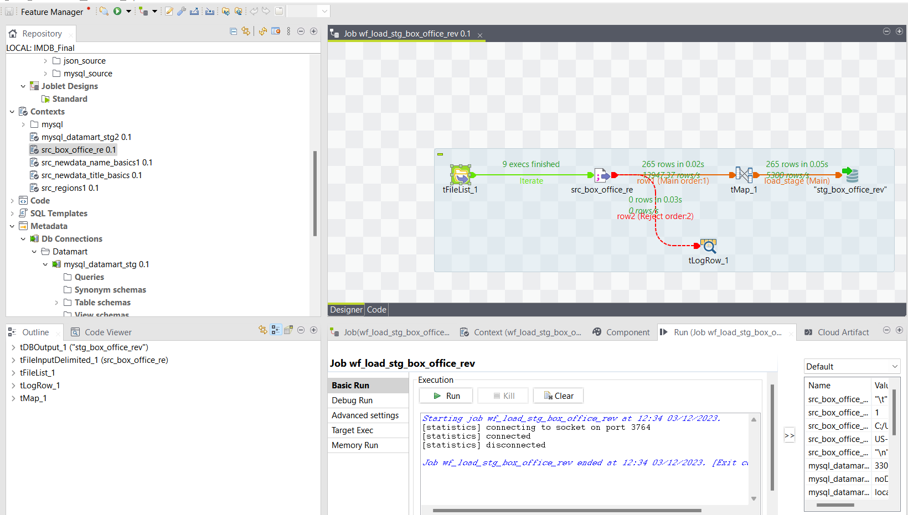

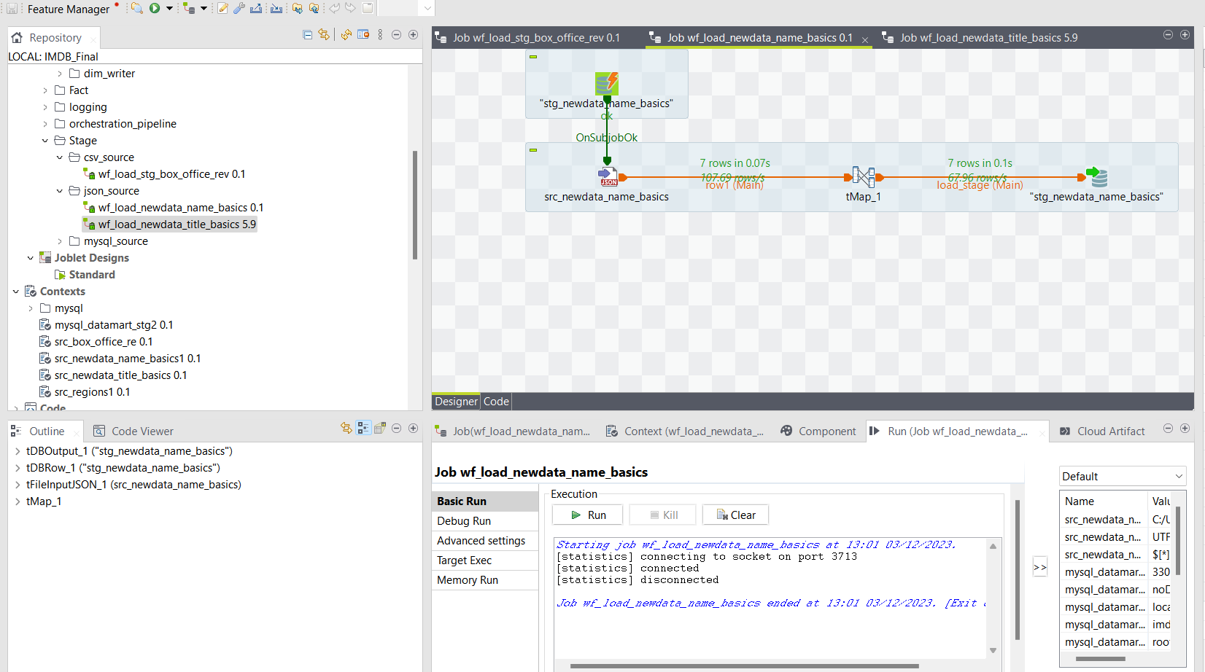

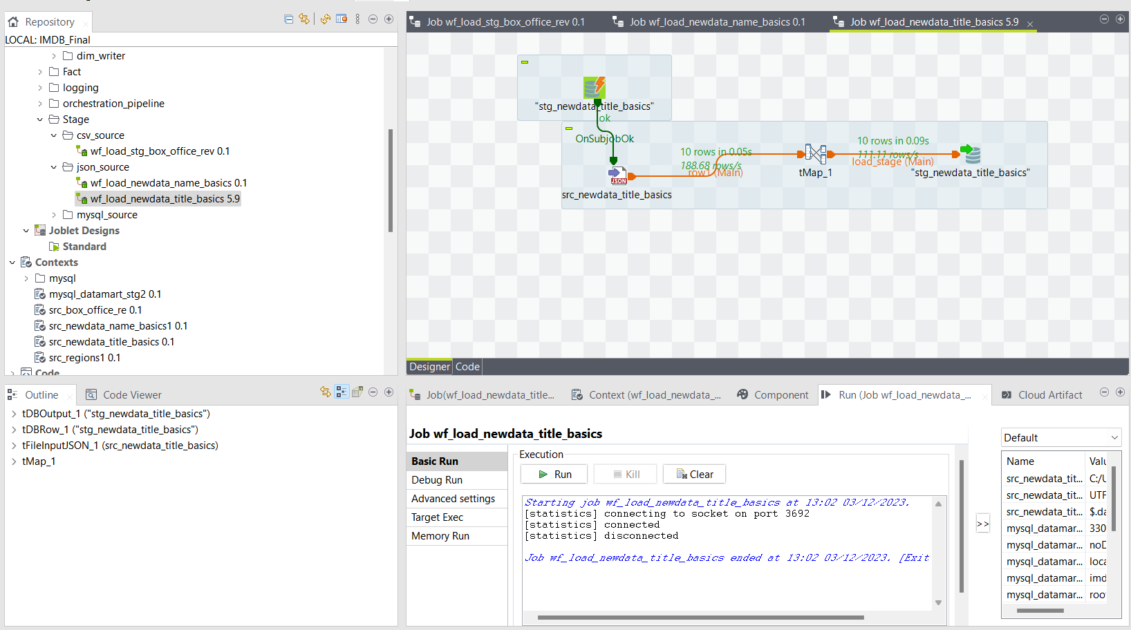

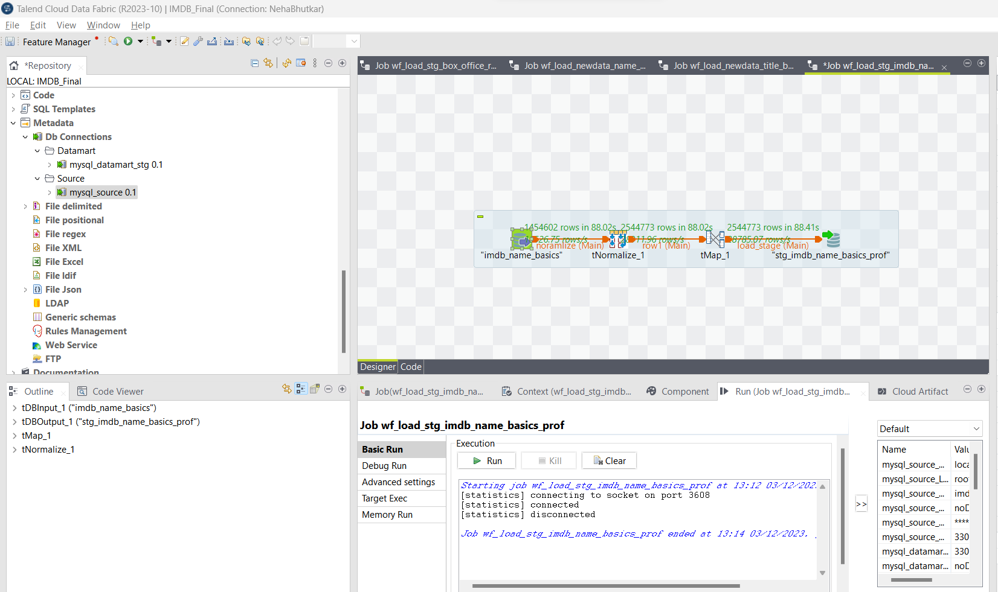

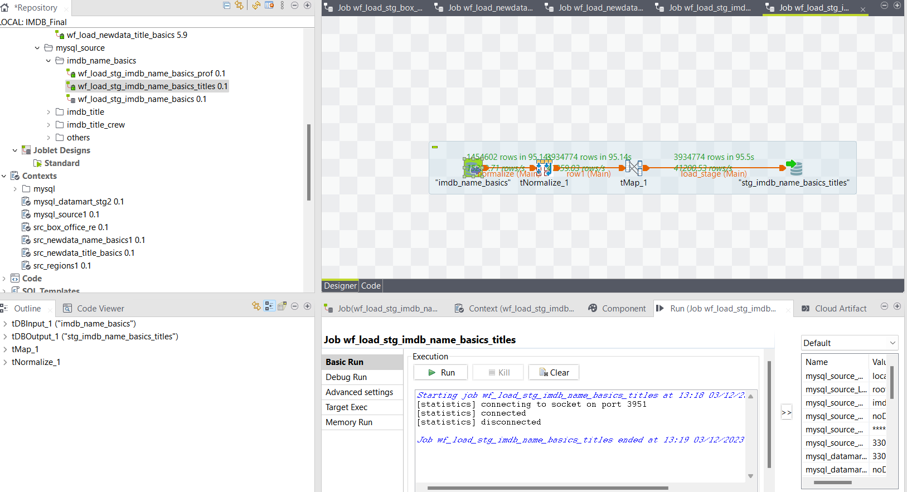

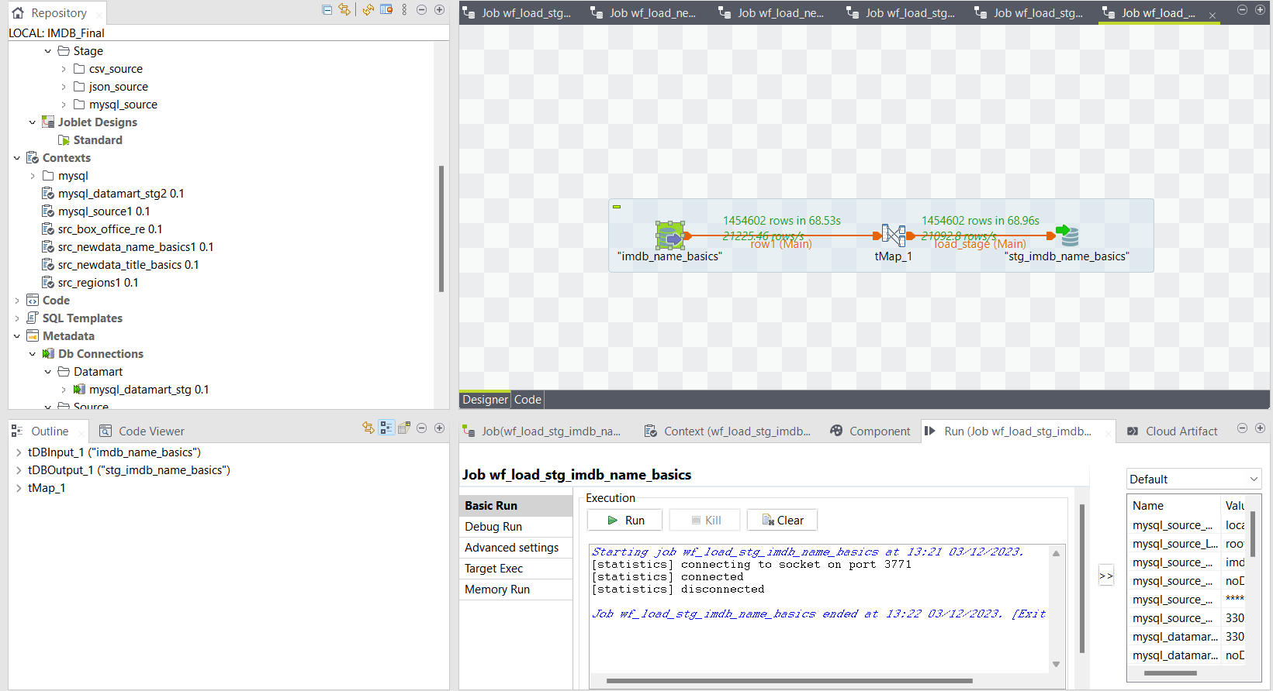

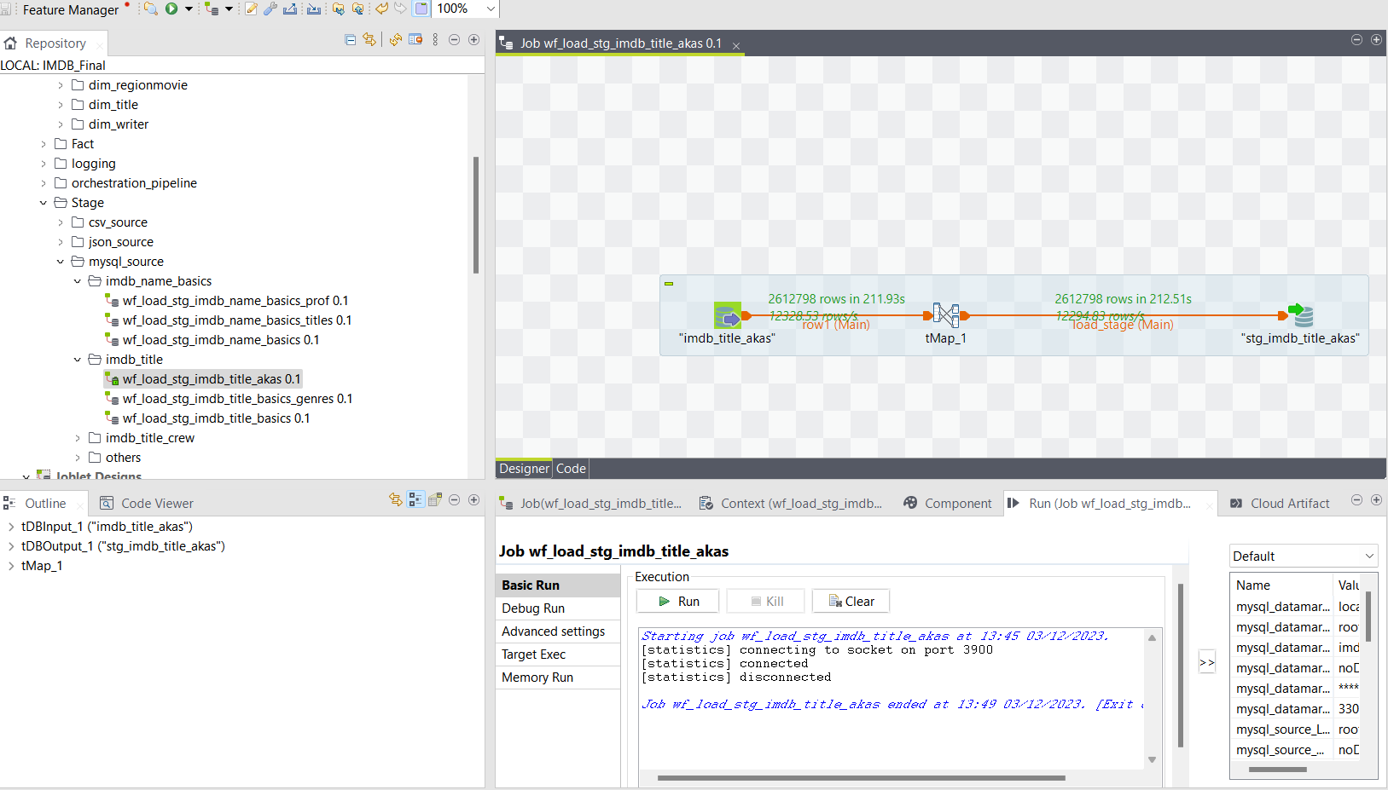

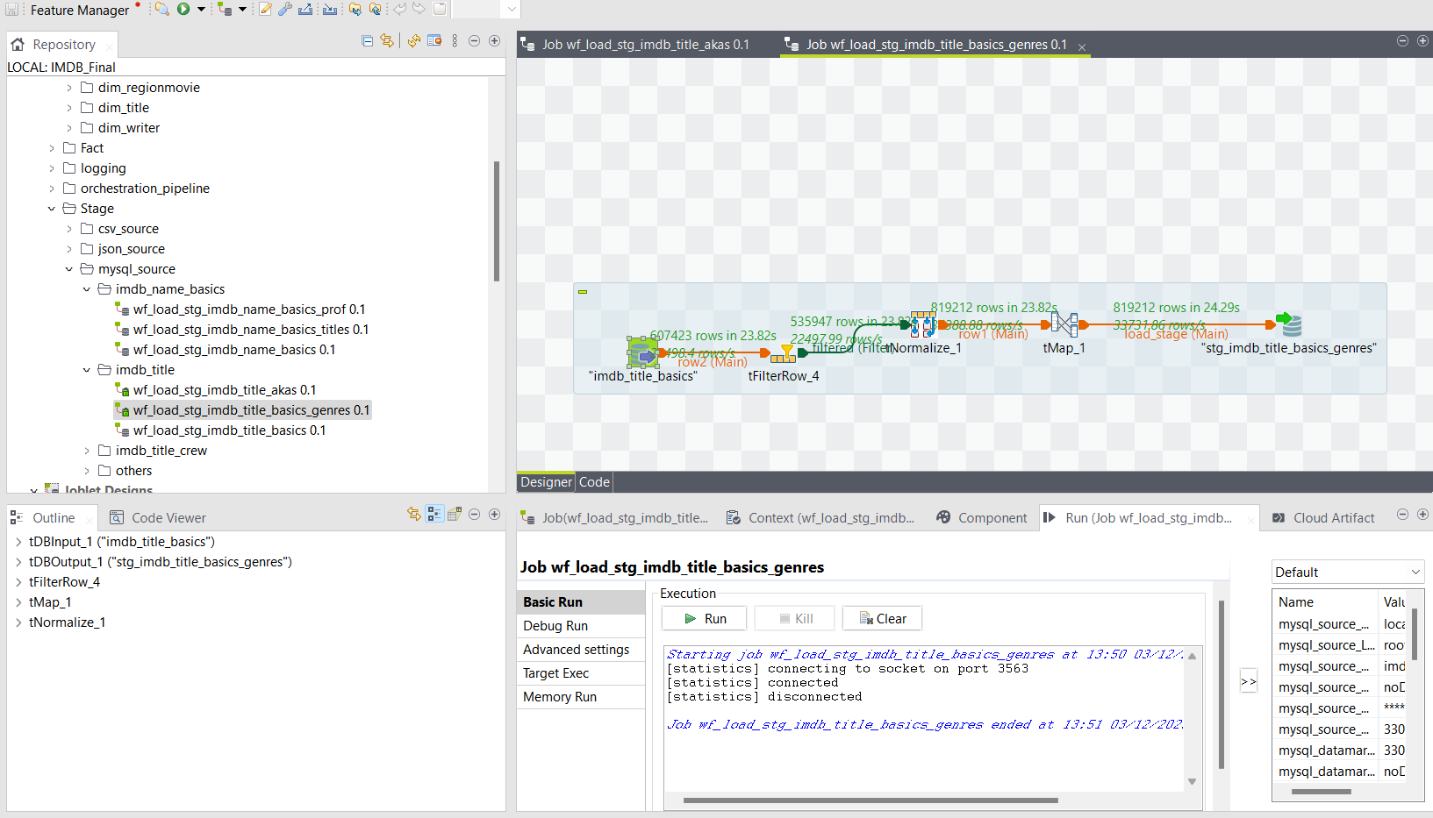

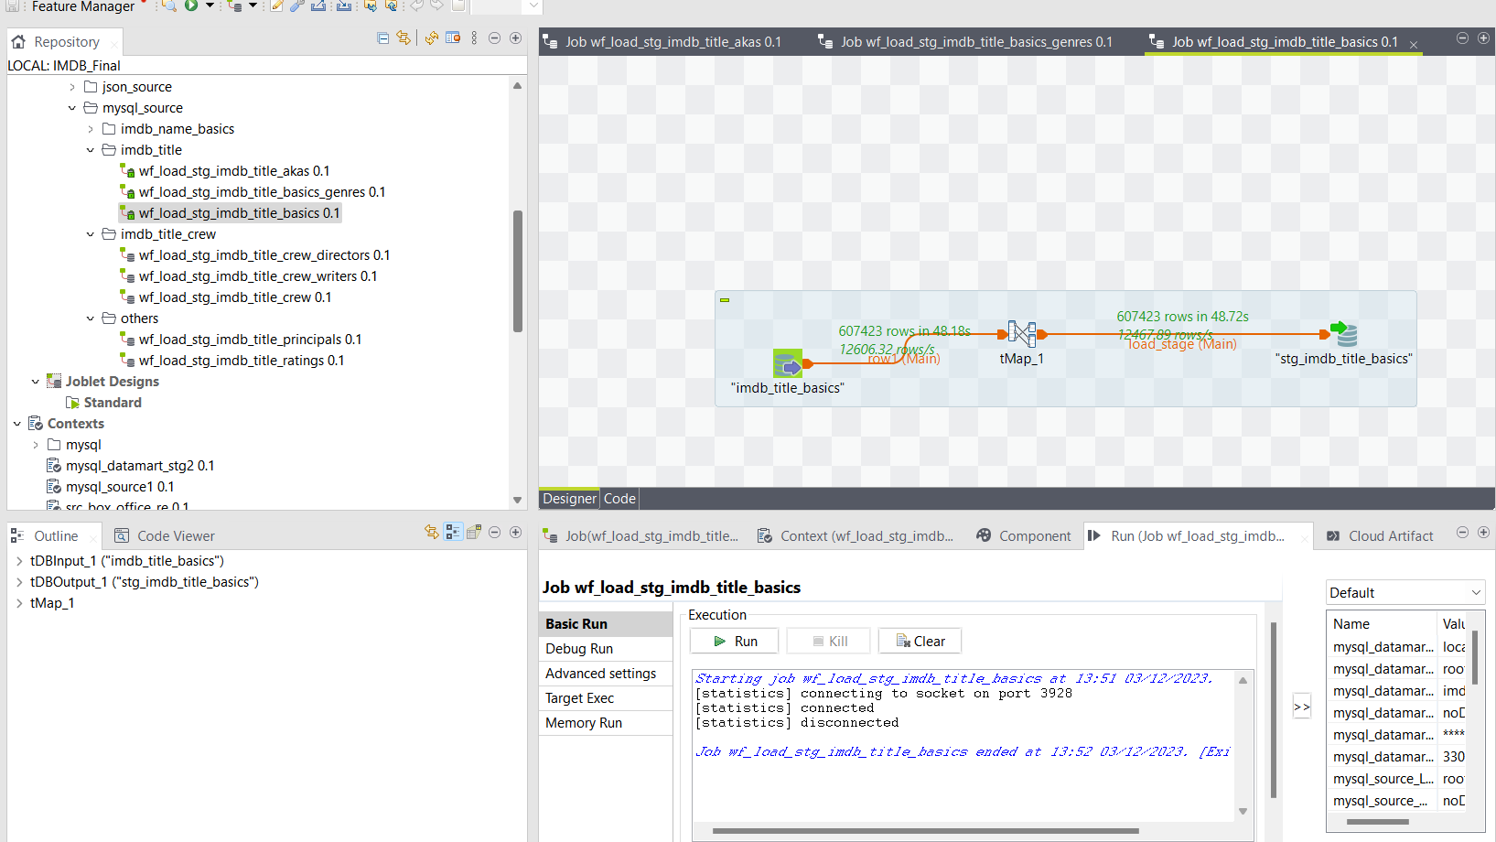

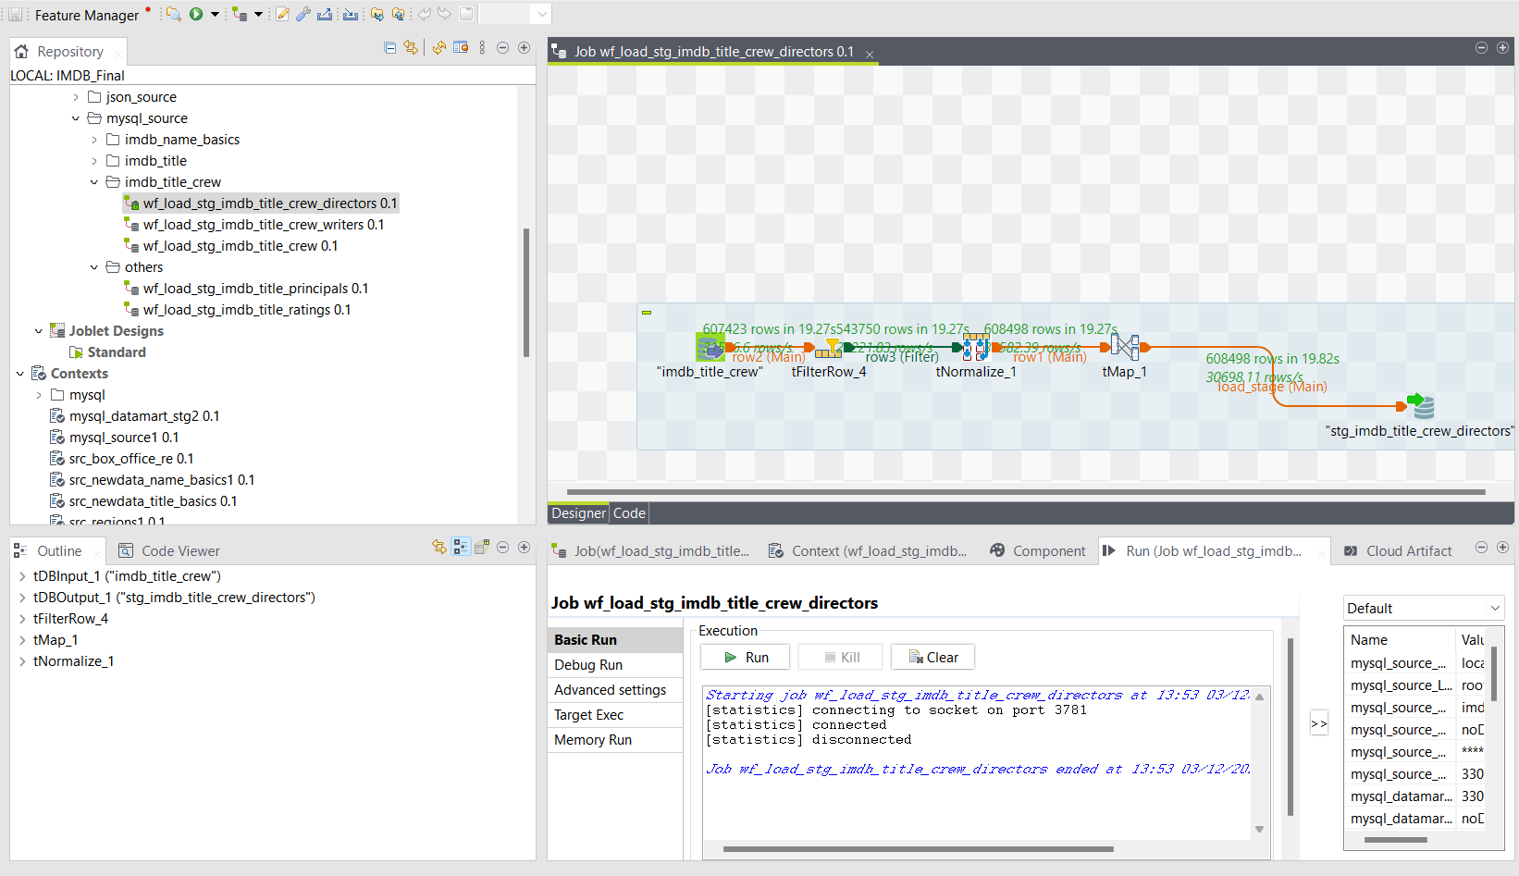

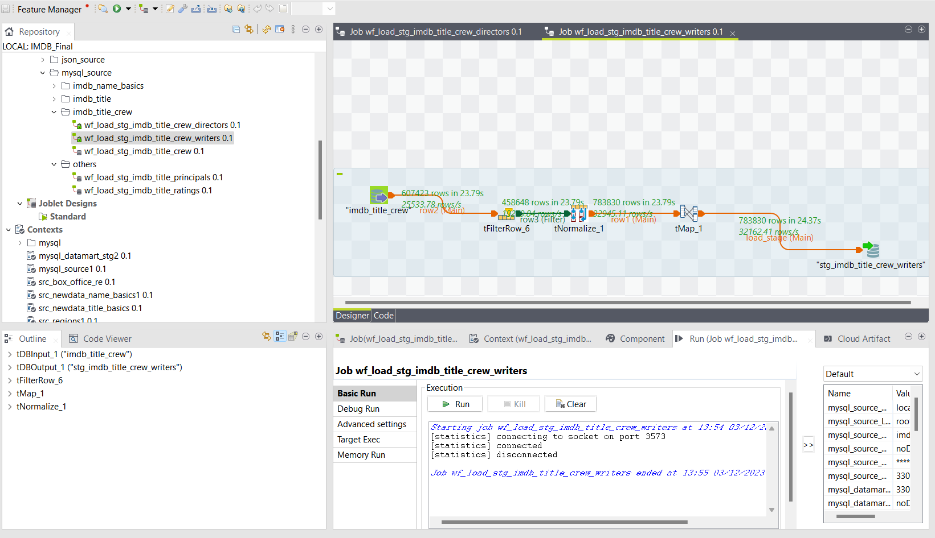

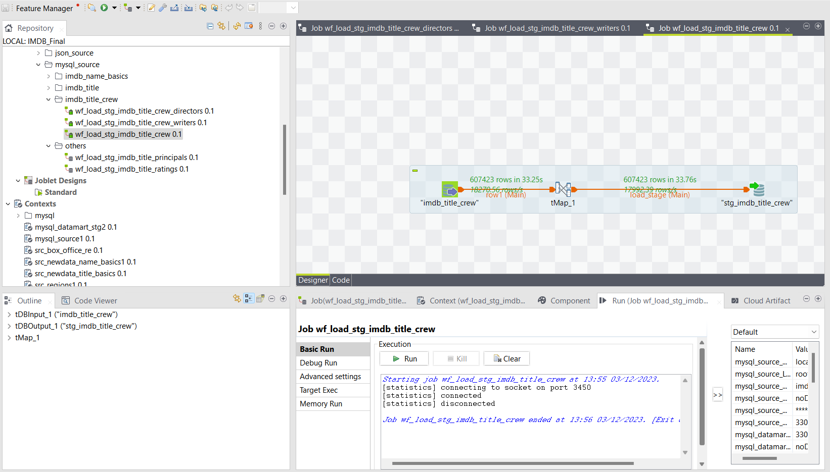

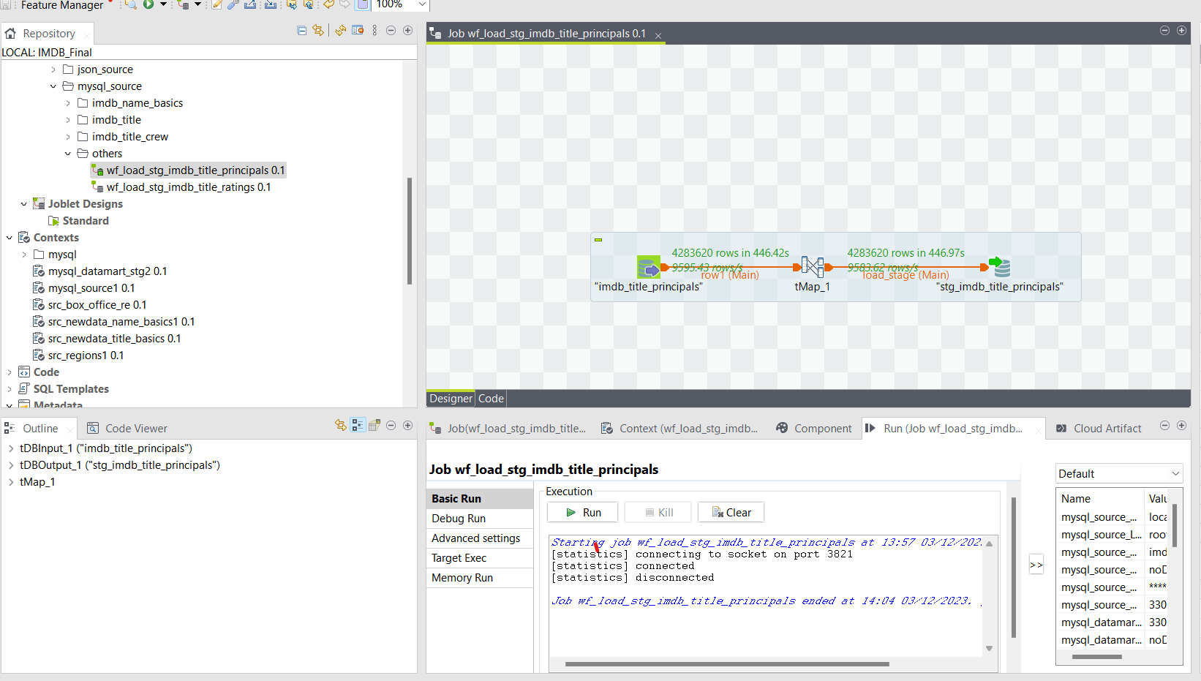

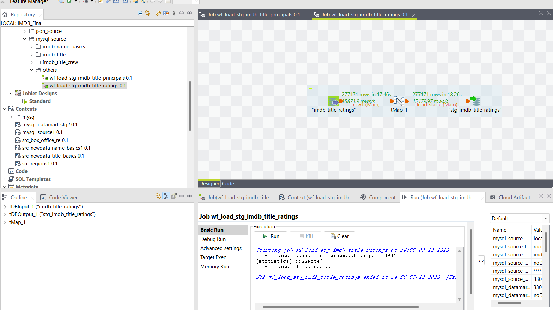

**SQL Query Data and Count for Staging Table –**

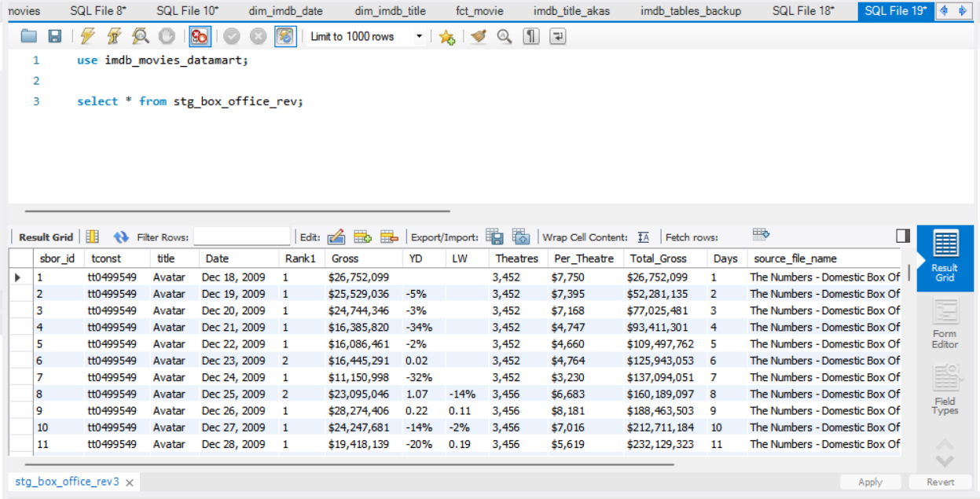

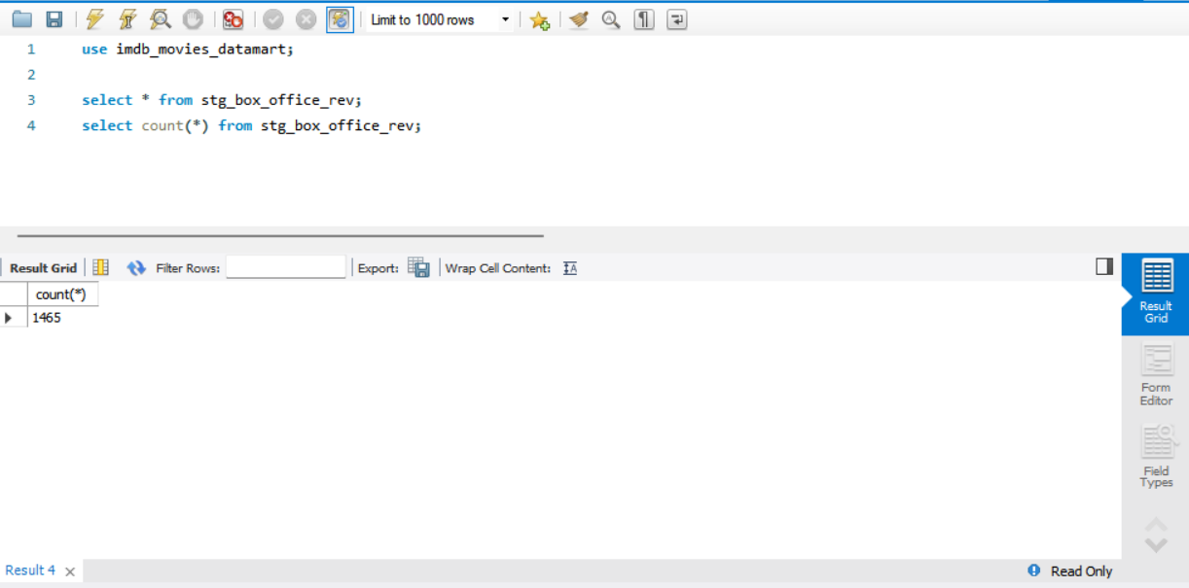

**Stg_imdb_name_basics –**

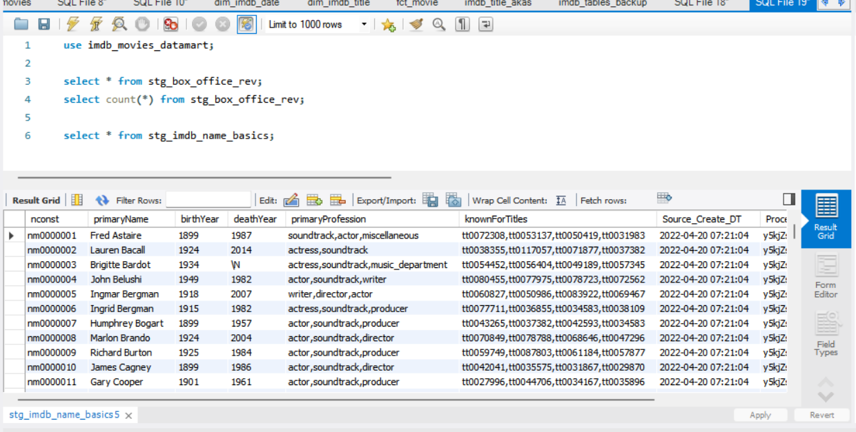

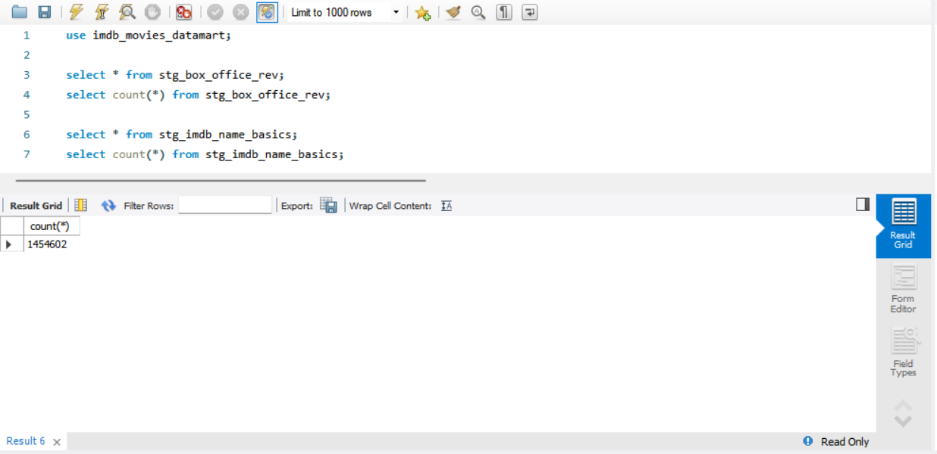

**Stg_imdb_name_basics_prof**

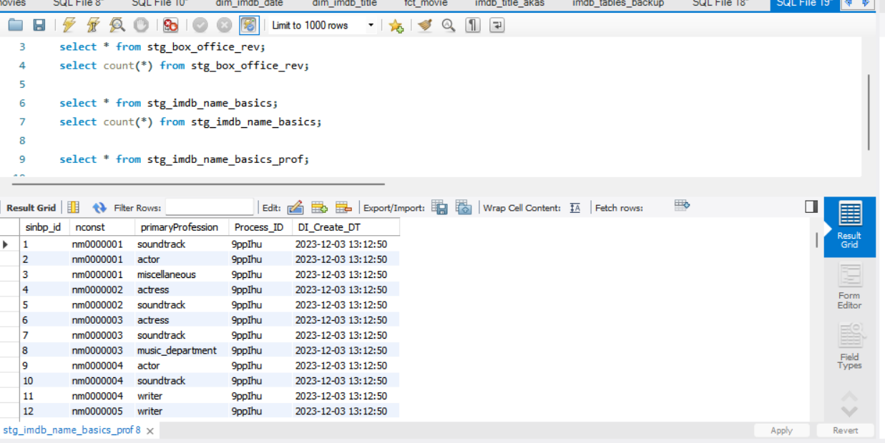

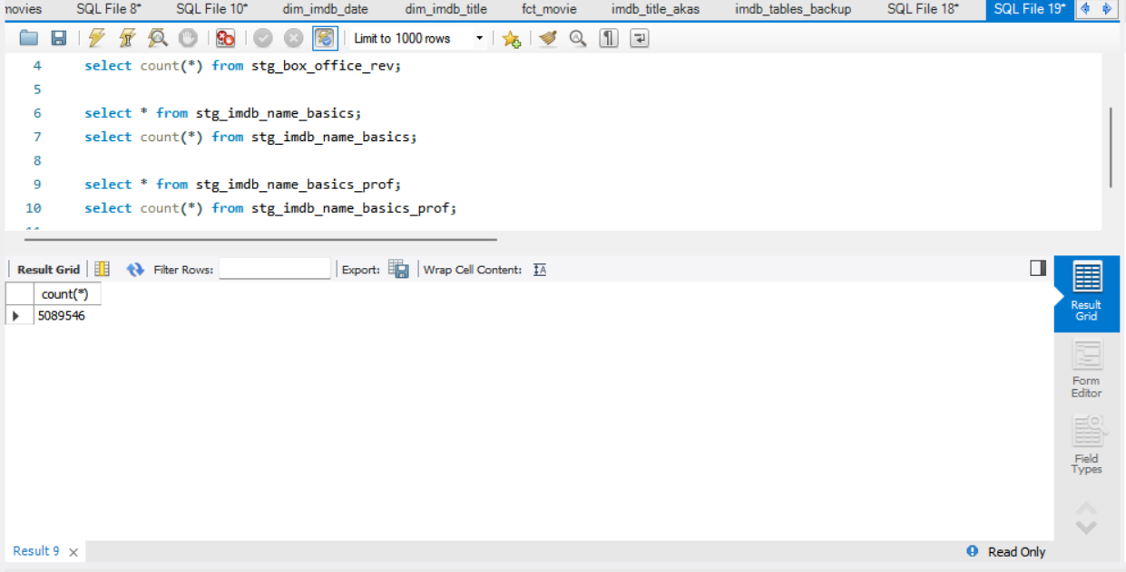

**stg_imdb_name_basics_titles**

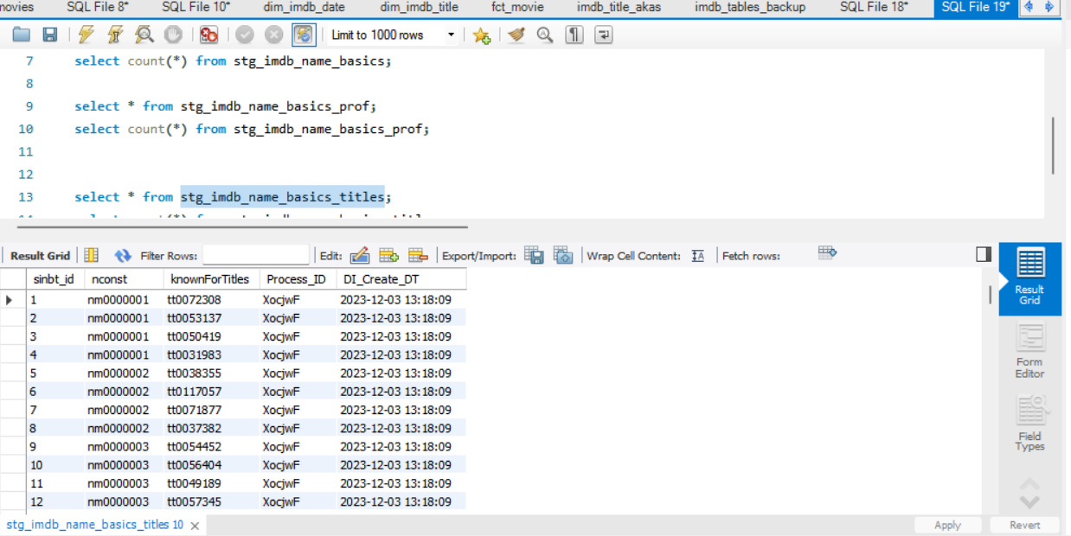

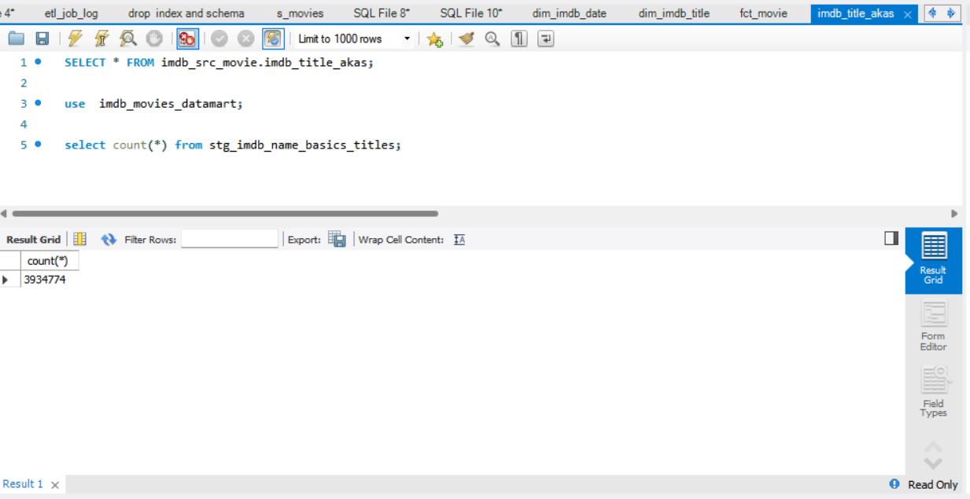

**Stg_imdb_title_akas –**

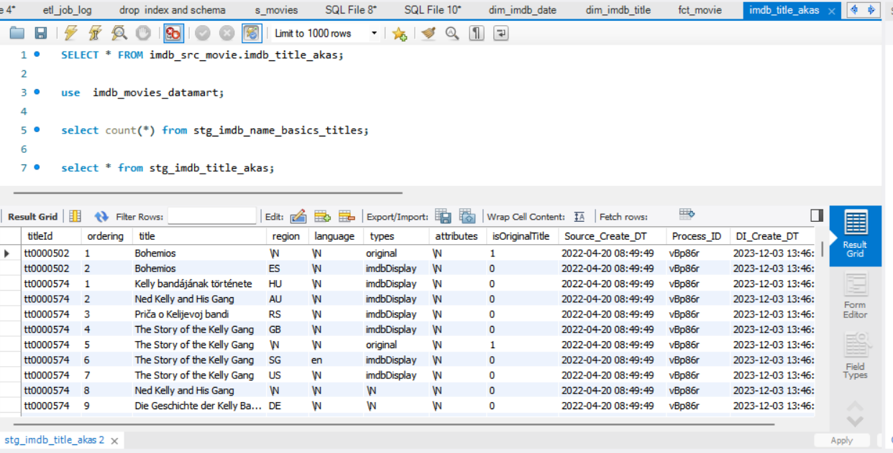

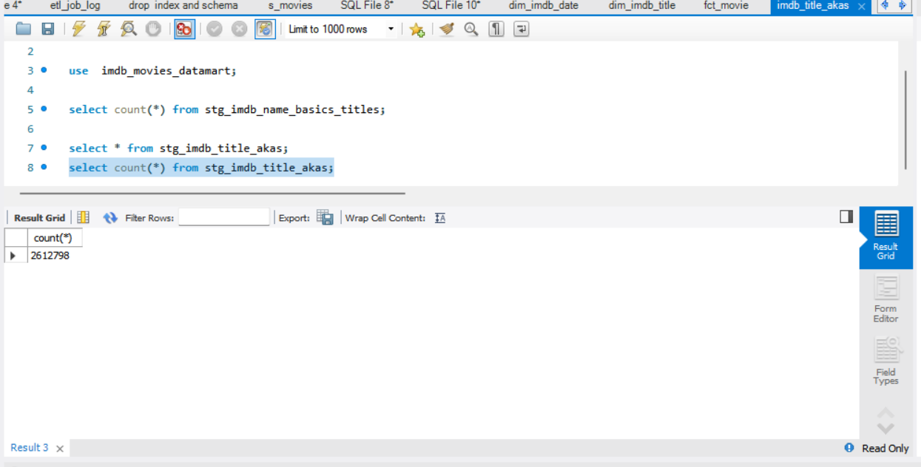

**Stg_imdb_title_basics –**

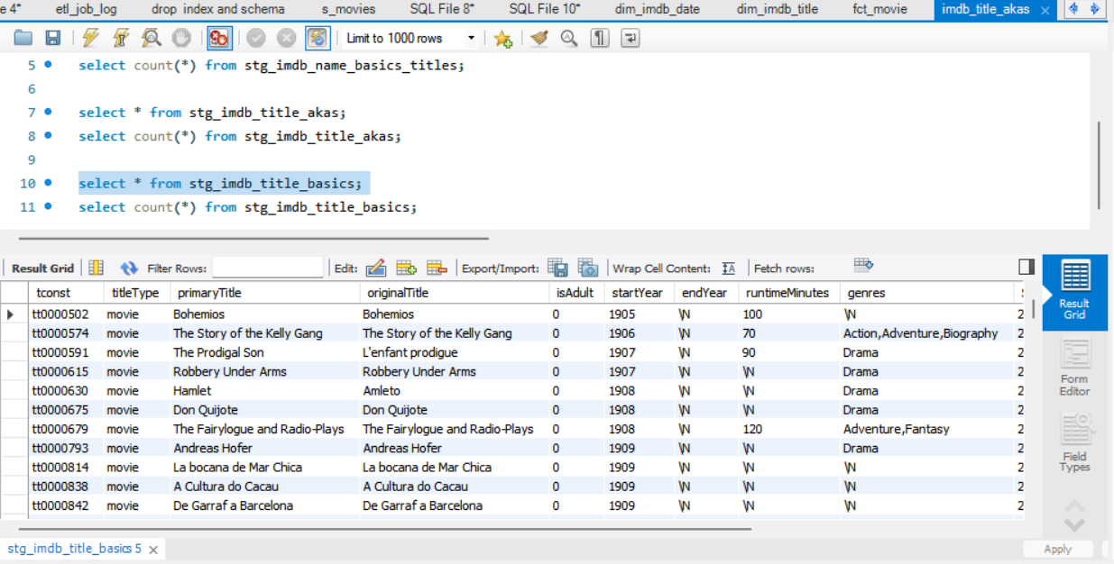

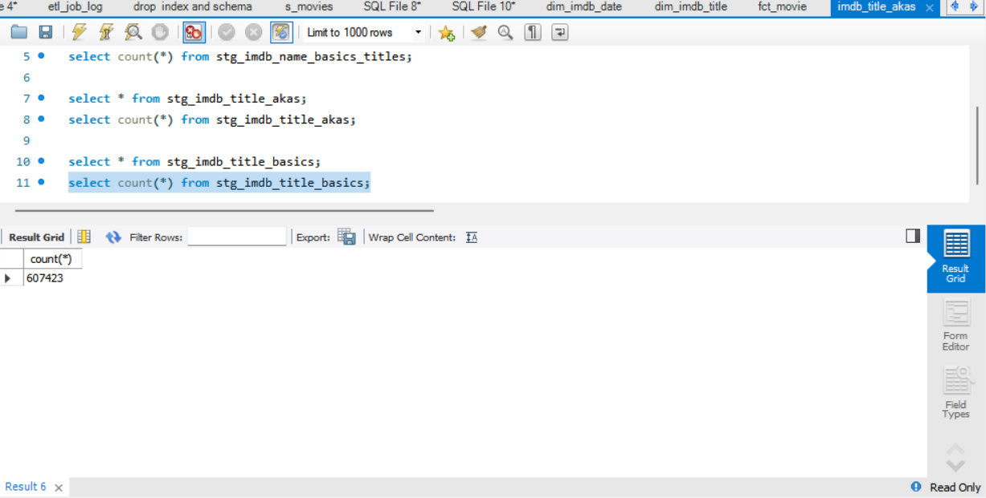

**Stg_imdb_name_basics_titles_genres –**

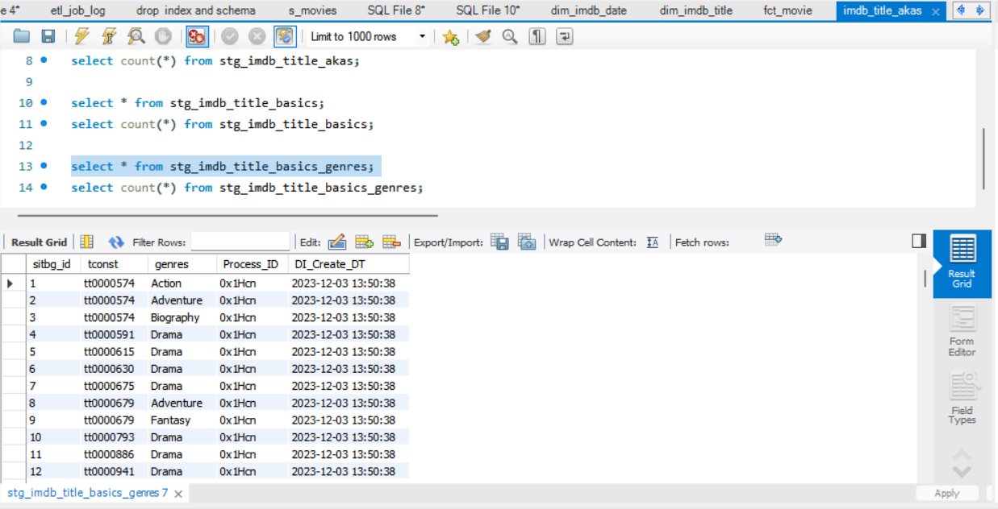

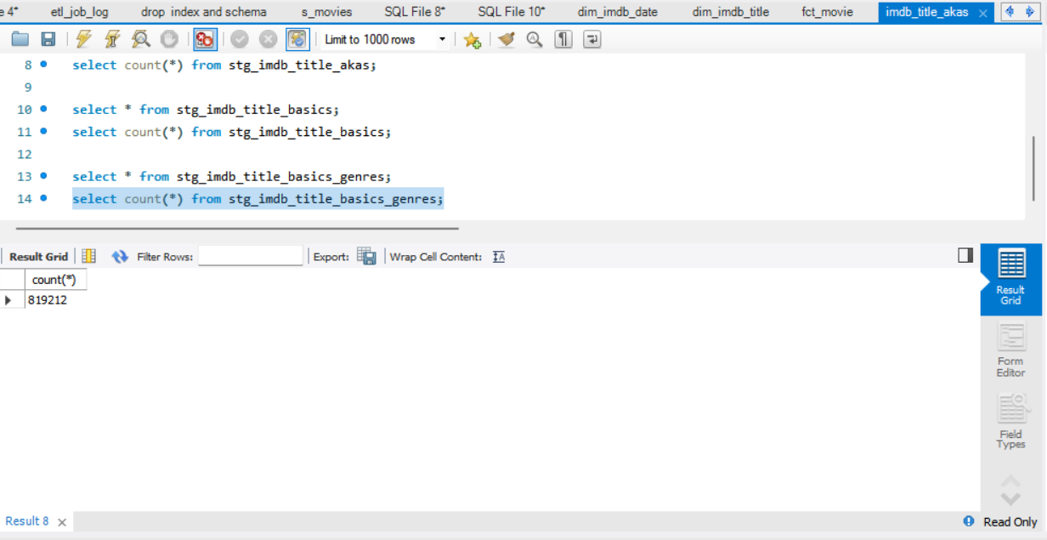

**Stg_imdb_title_crew –**

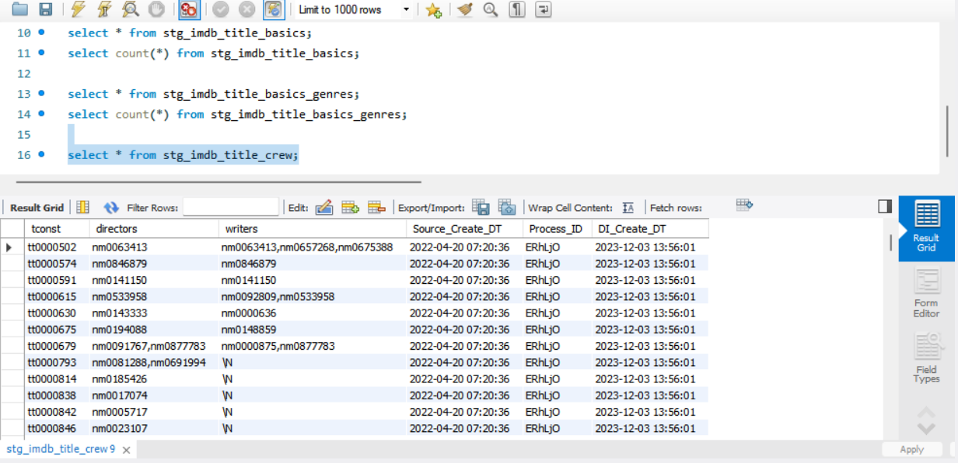

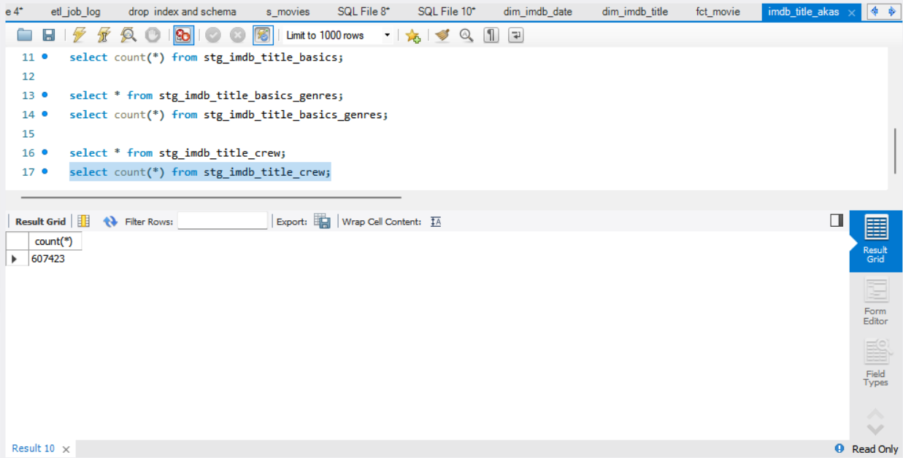

**Stg_imdb_title_crew_directors –**

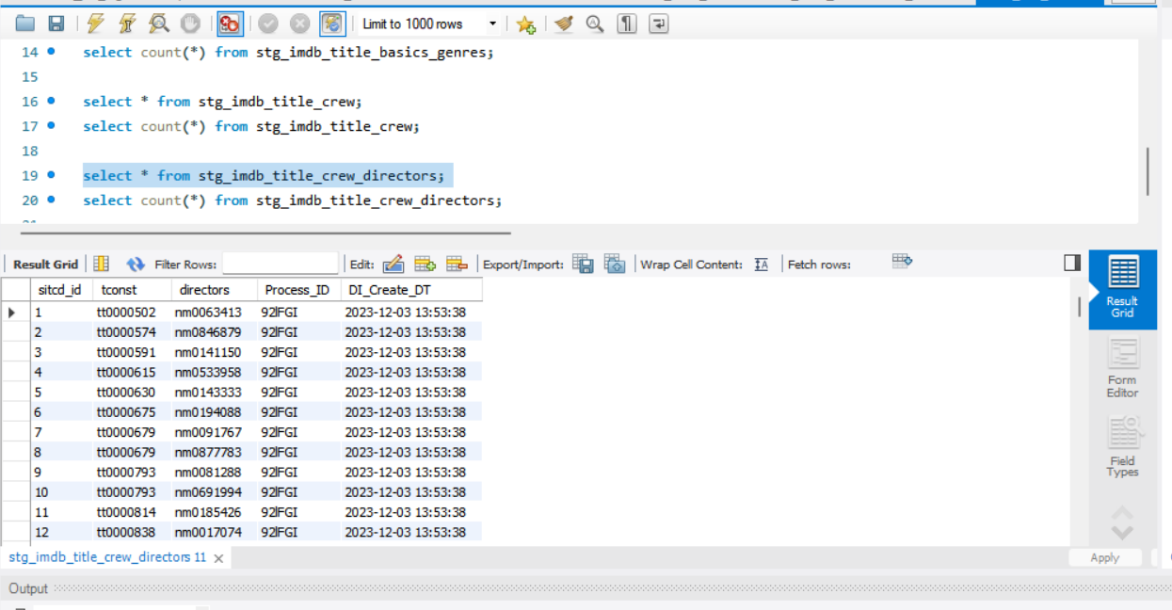

**\**

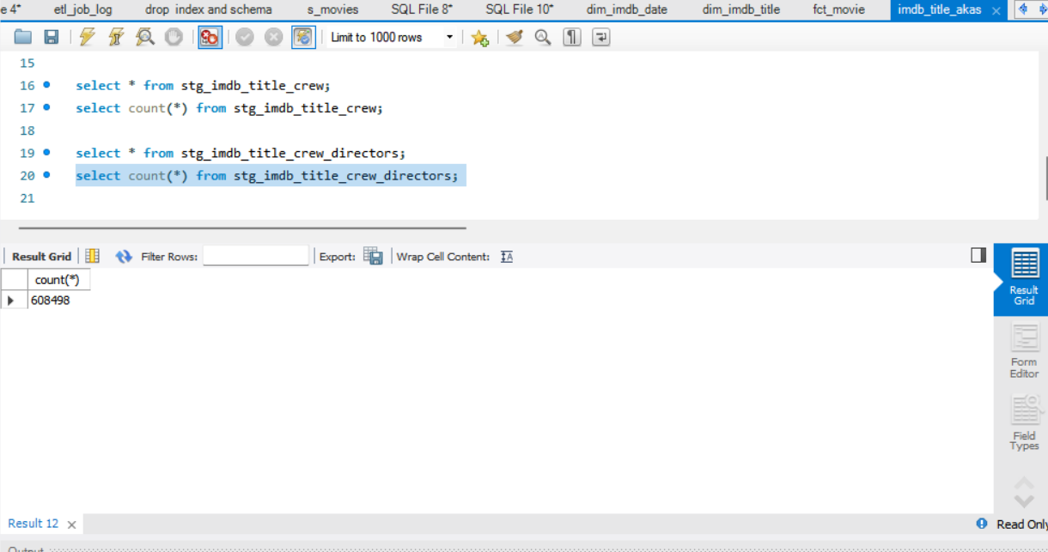

**Stg_imdb_title_crew_writers-**

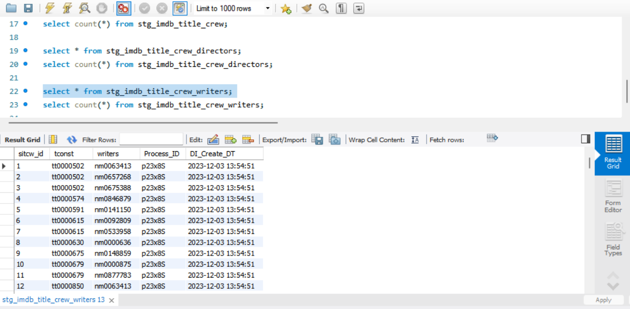

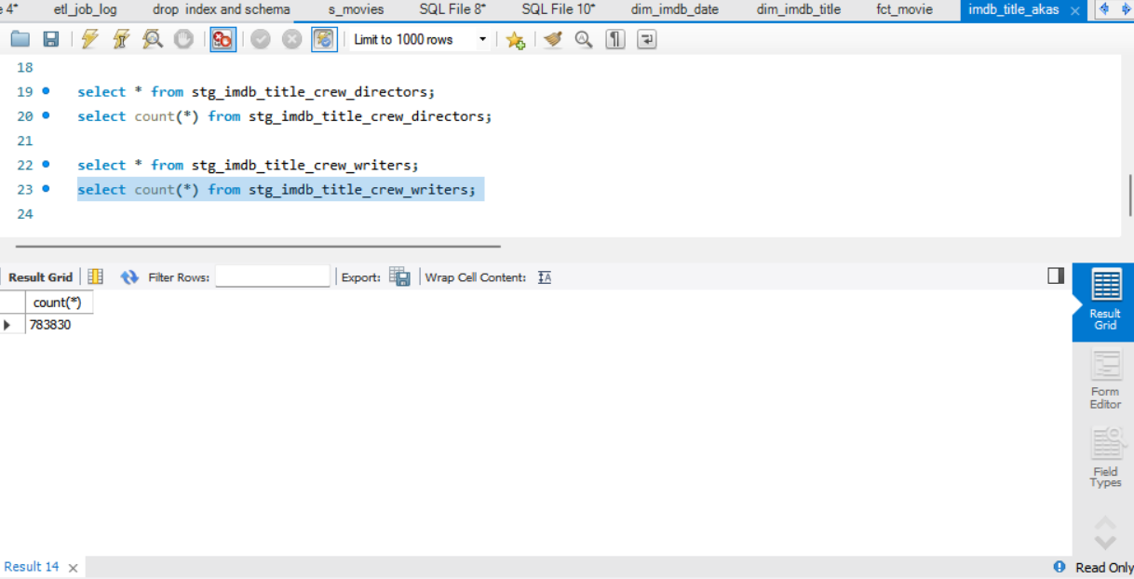

**Stg_imdb_title_principals –**

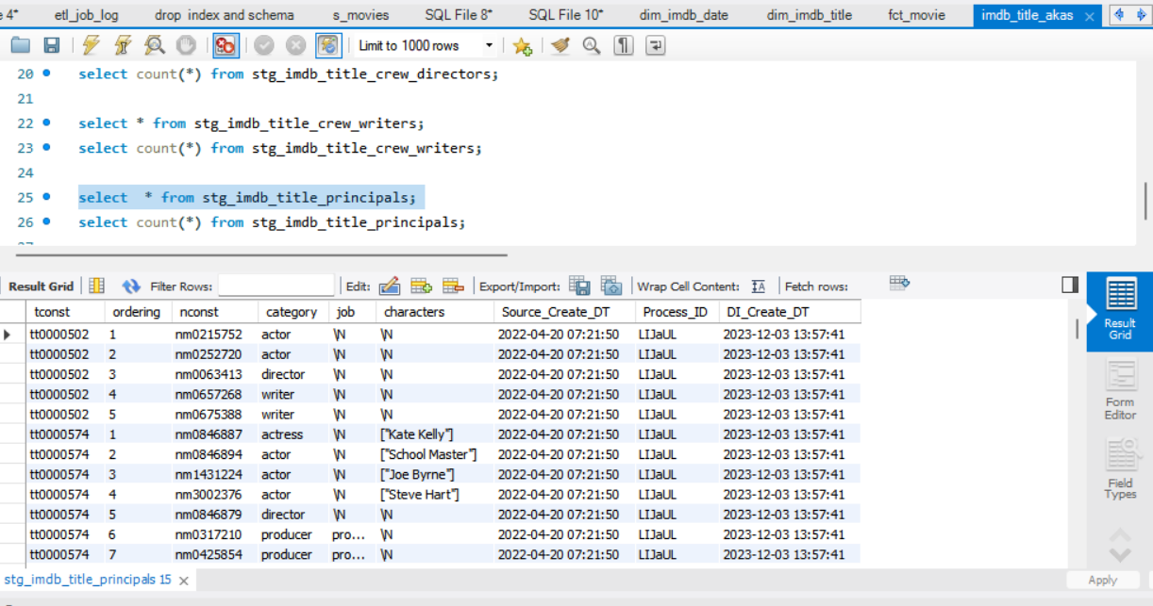

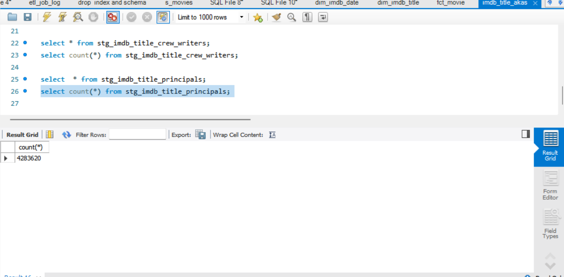

**Stg_imdb_title_ratings –**

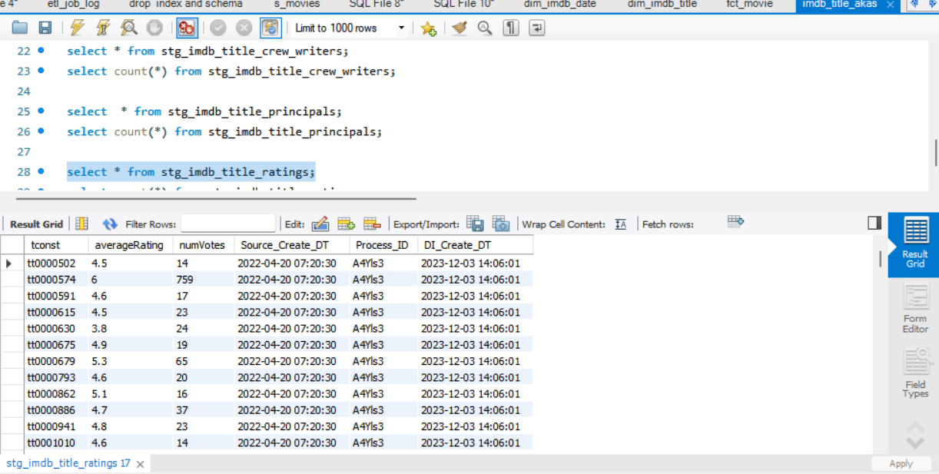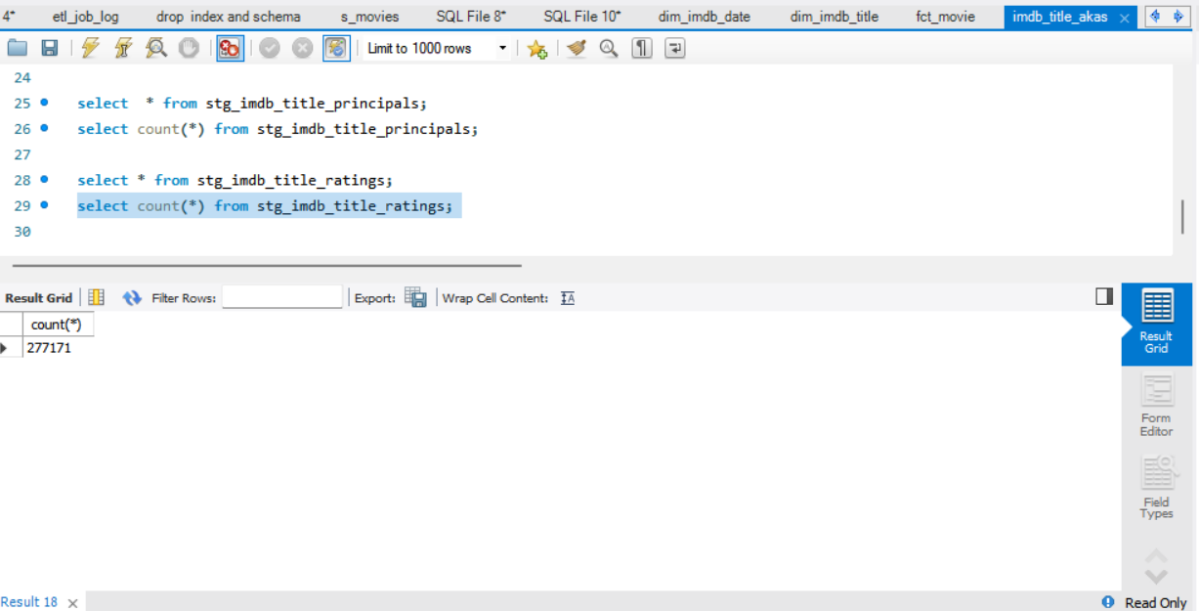

**Stg_newdata_name_basics –**

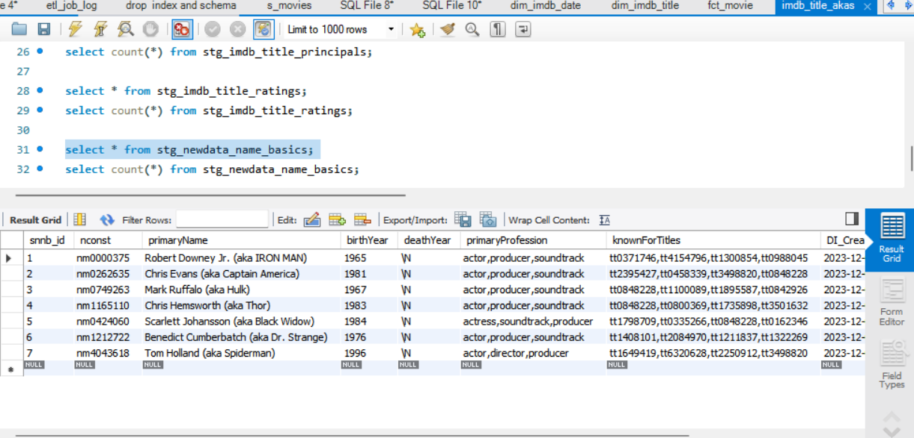

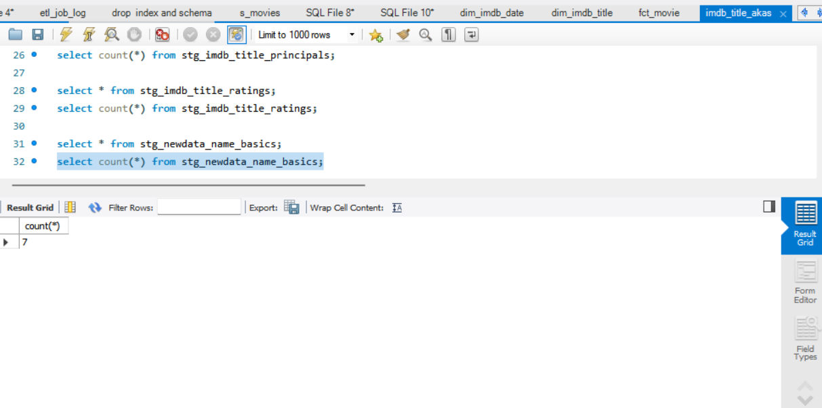

**Stg_newdata_title_basics –**

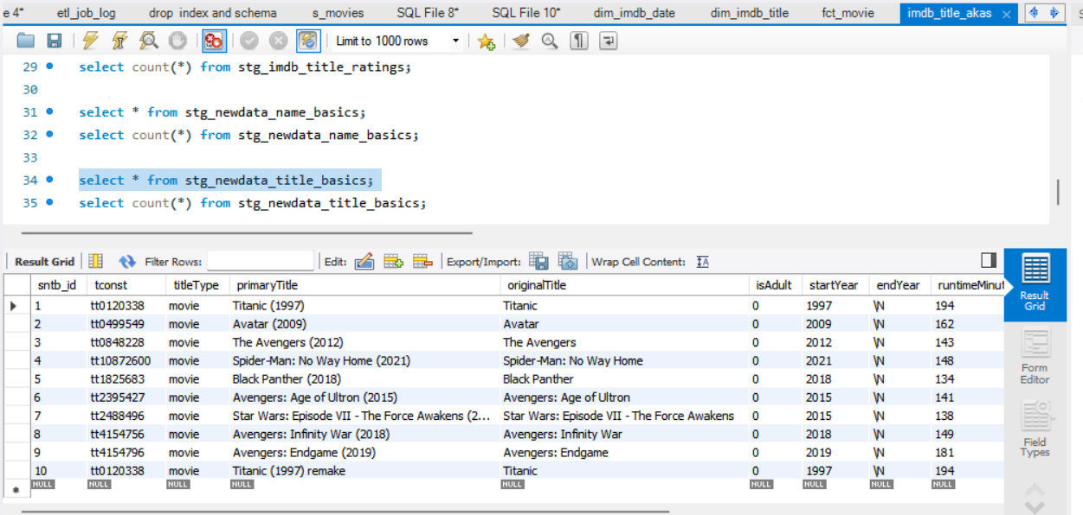

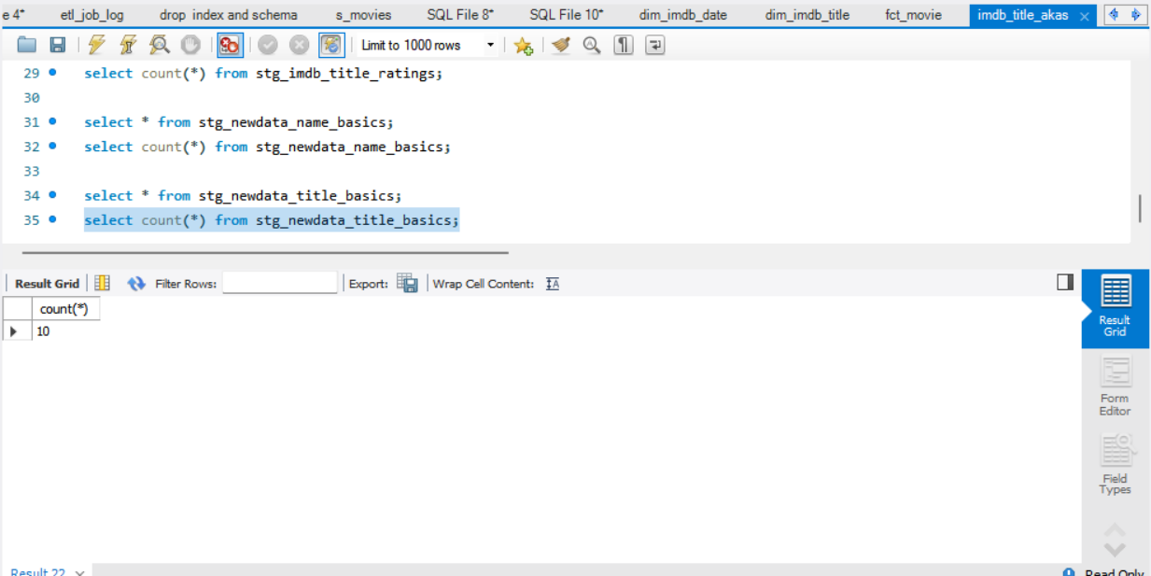

**DIM Loading:**

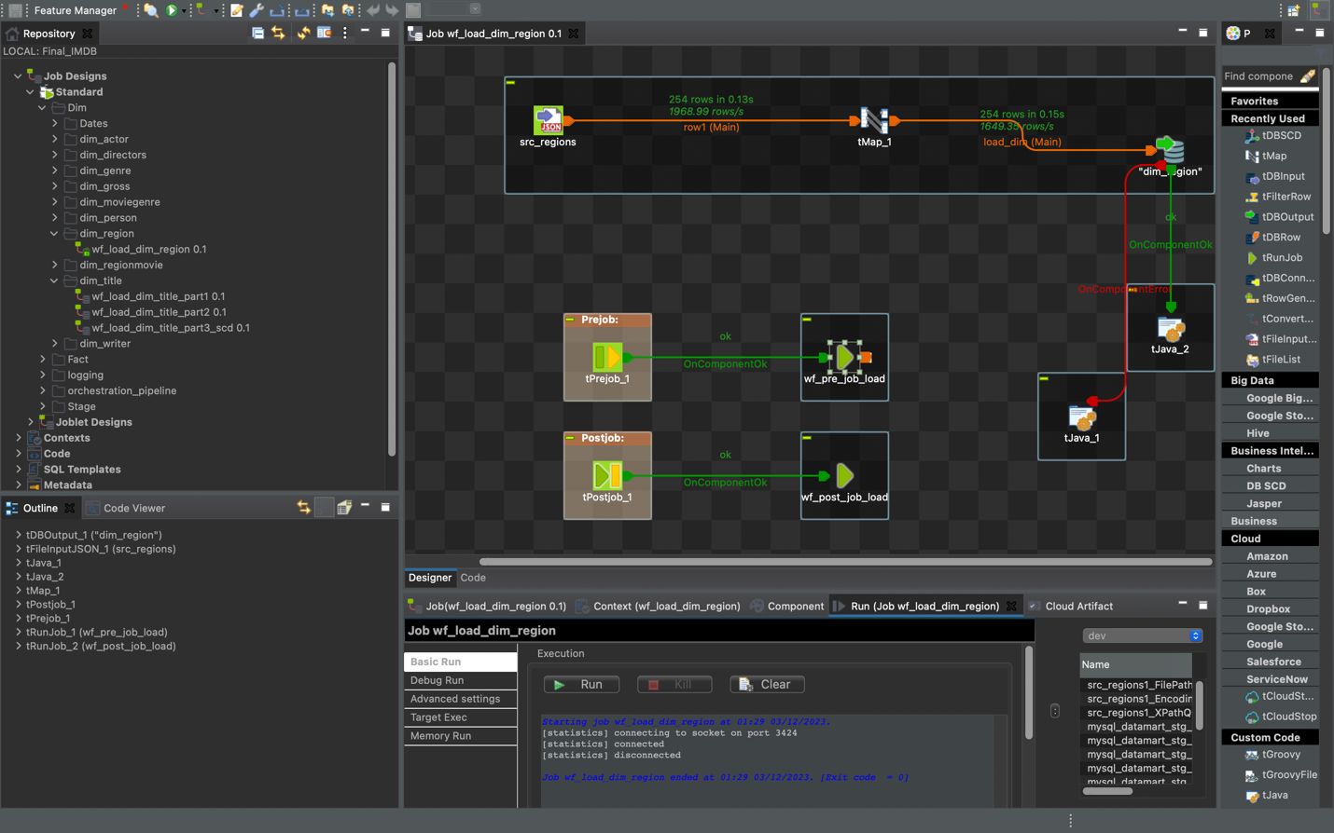

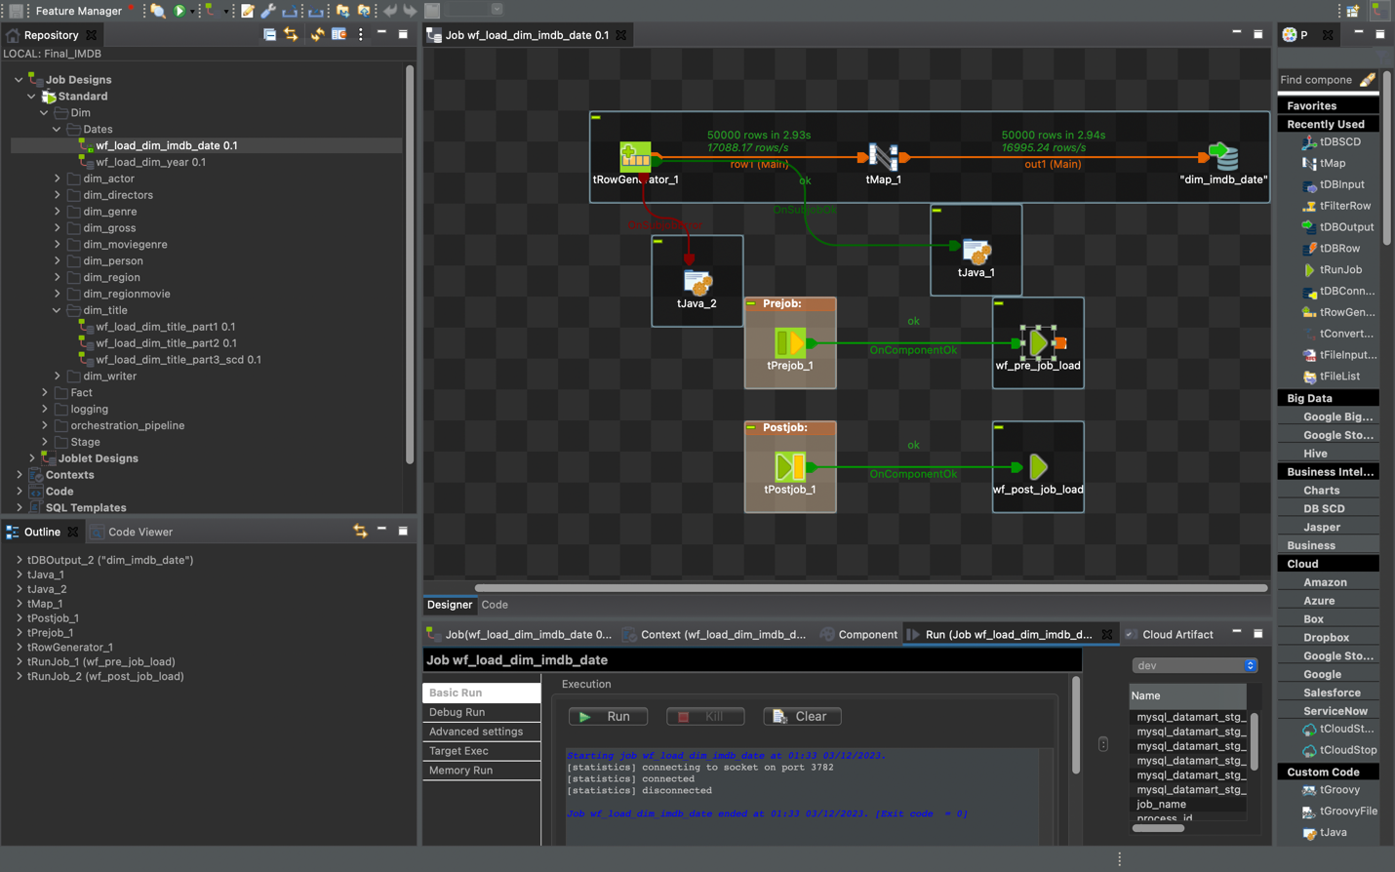

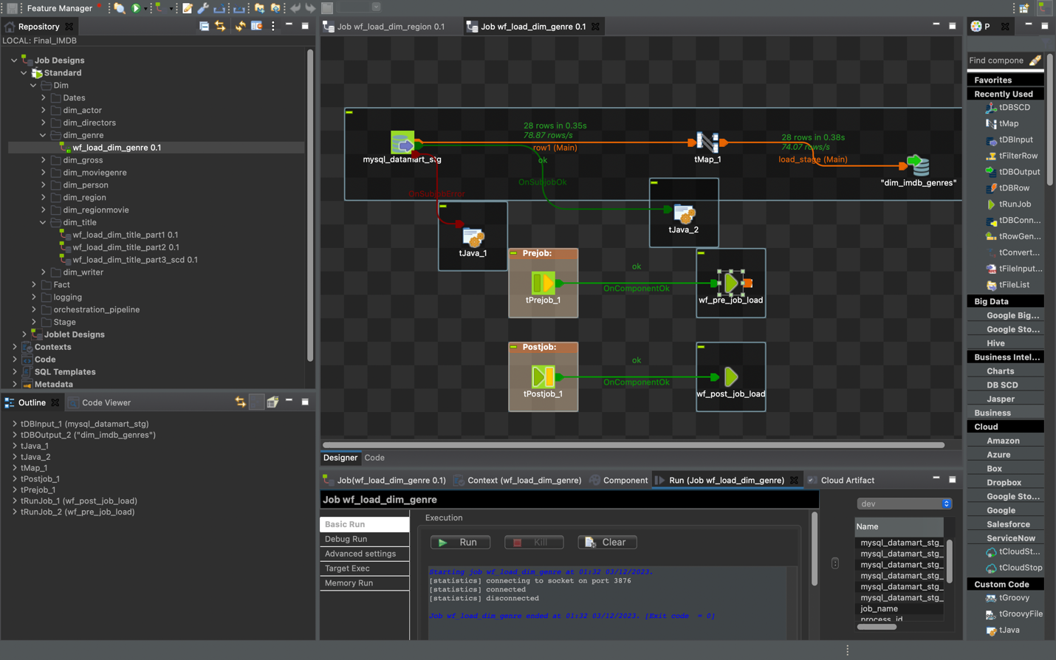

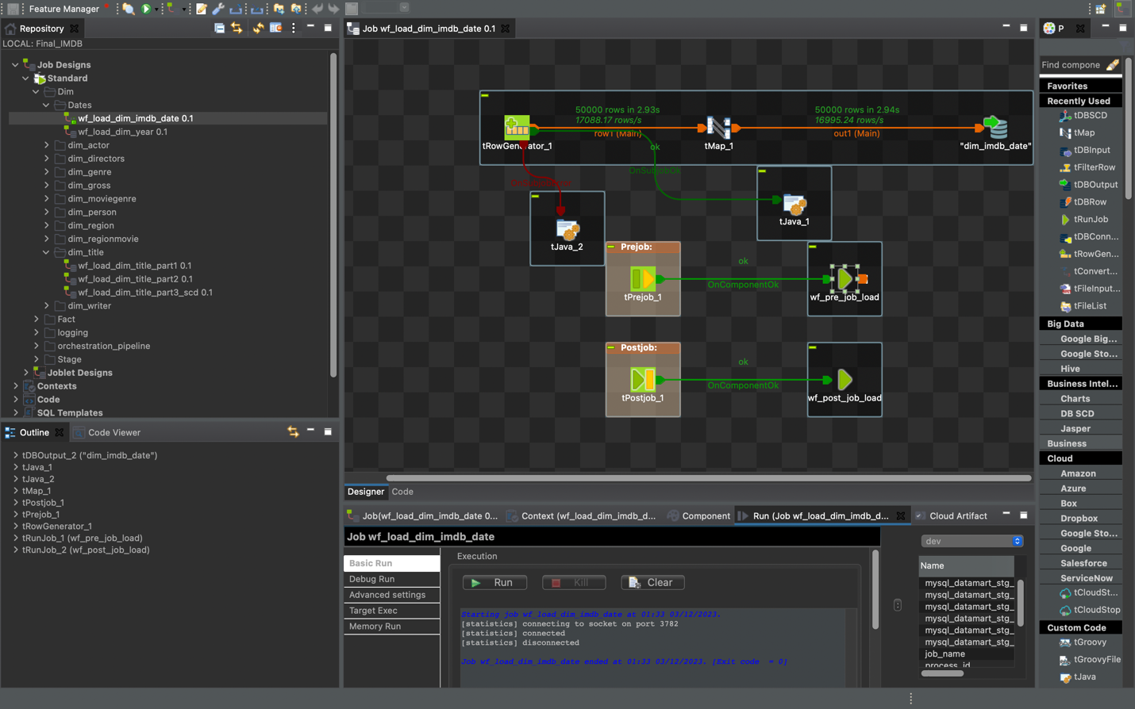

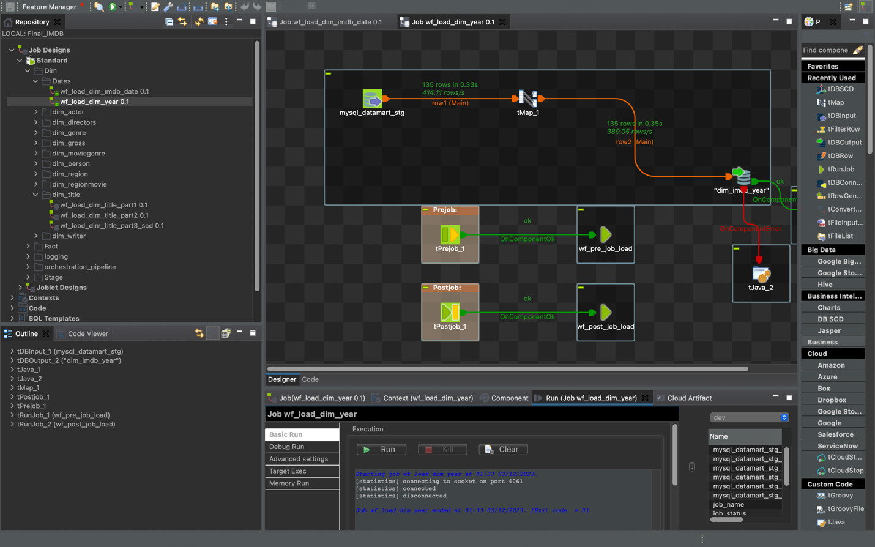

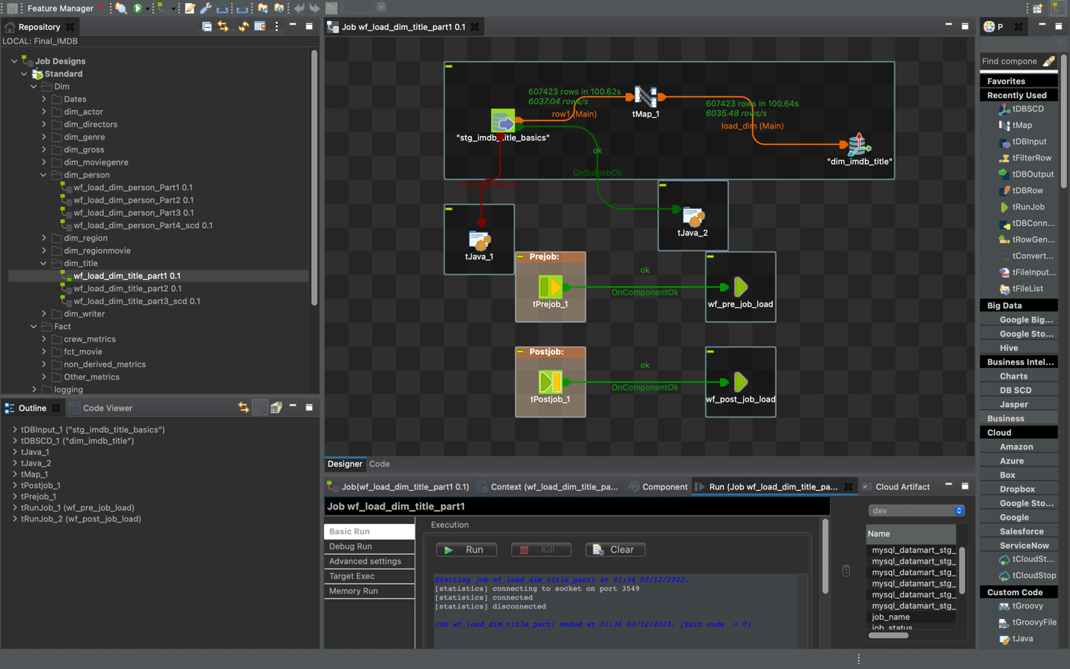

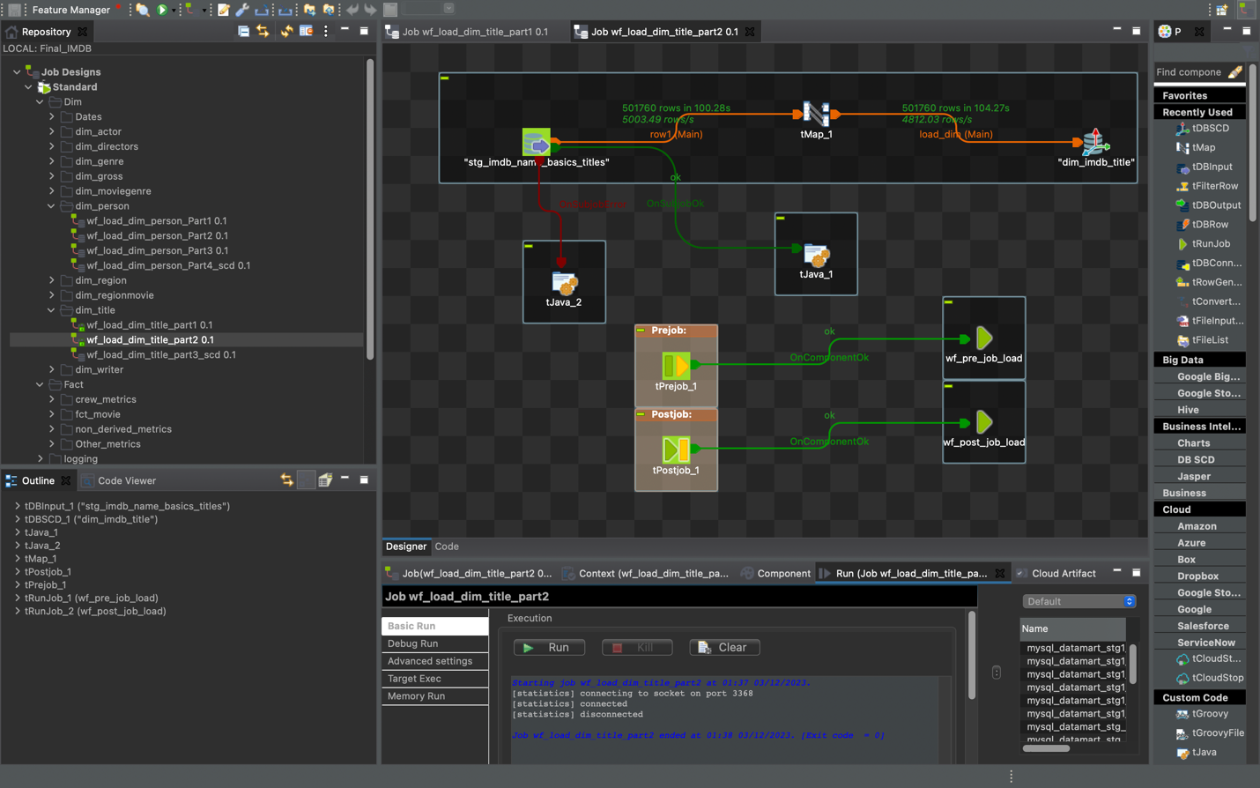

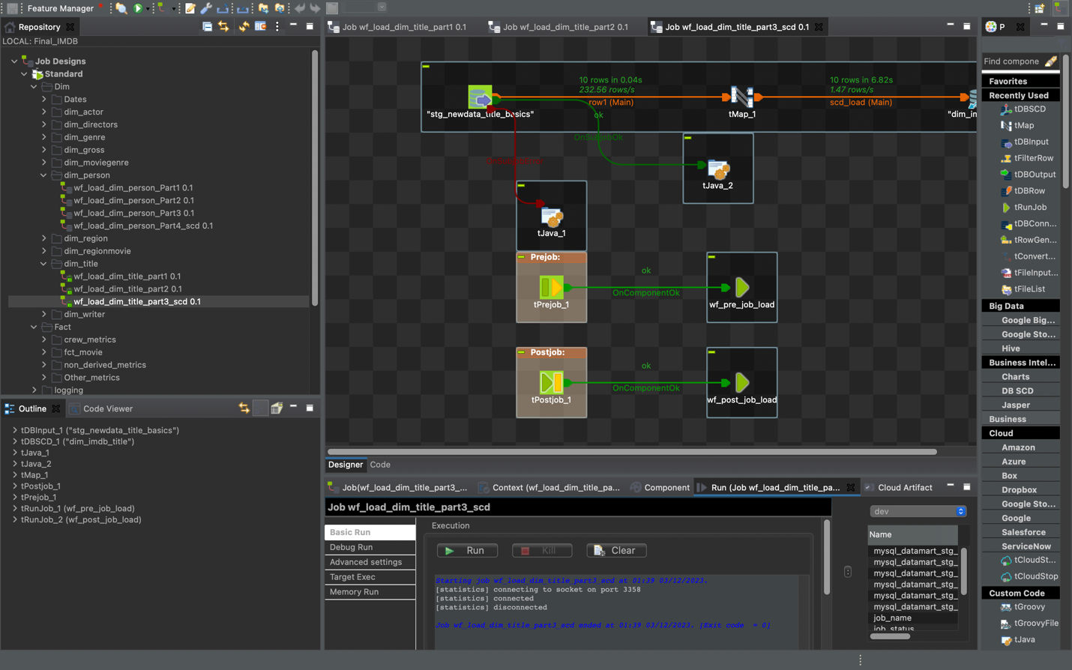

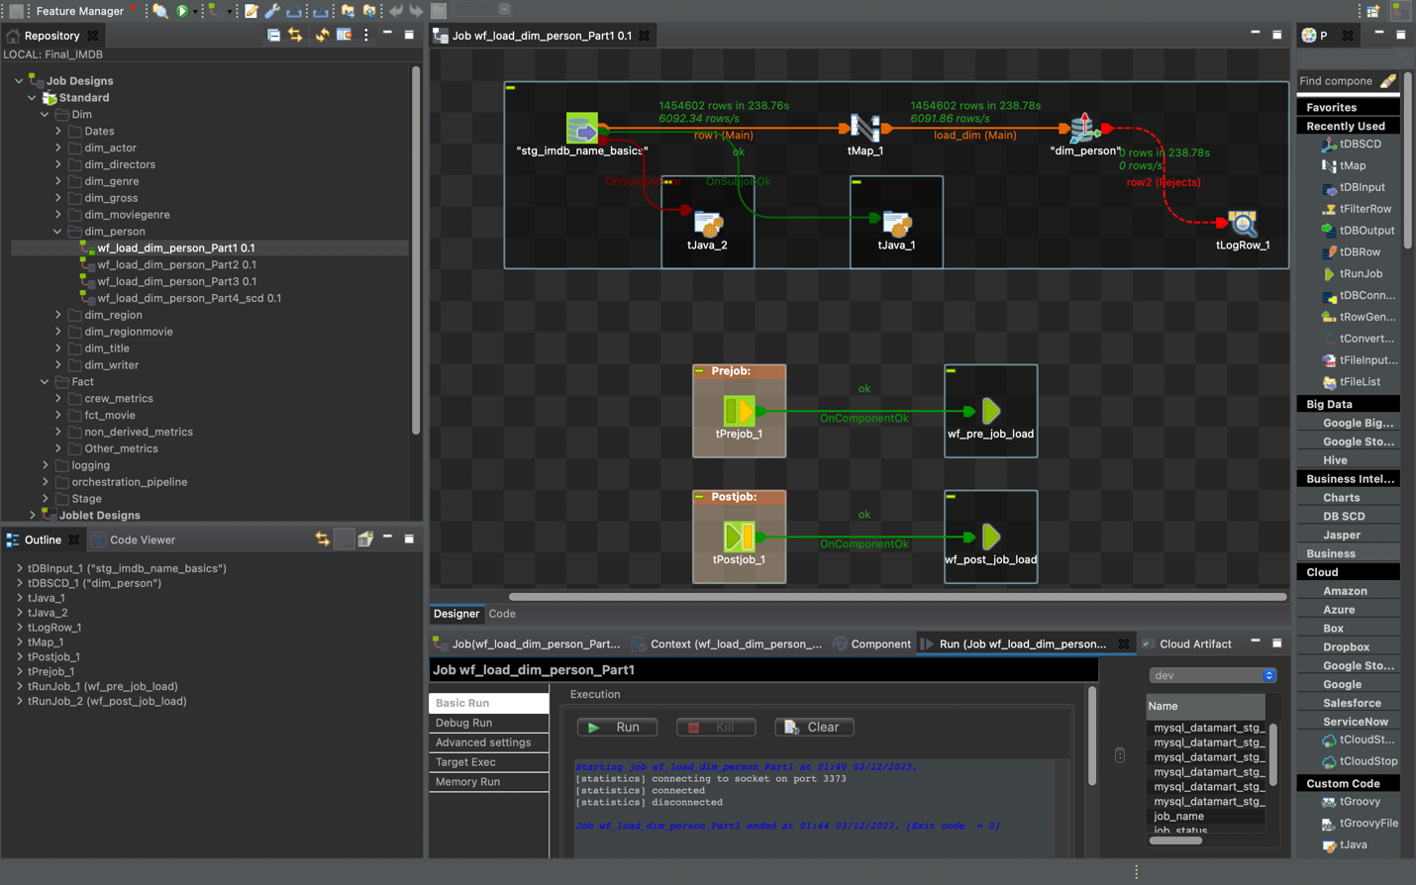

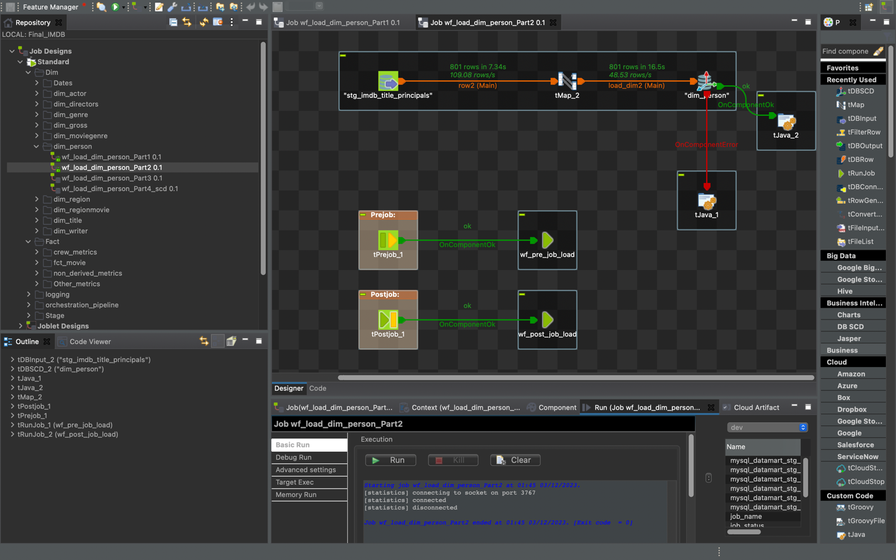

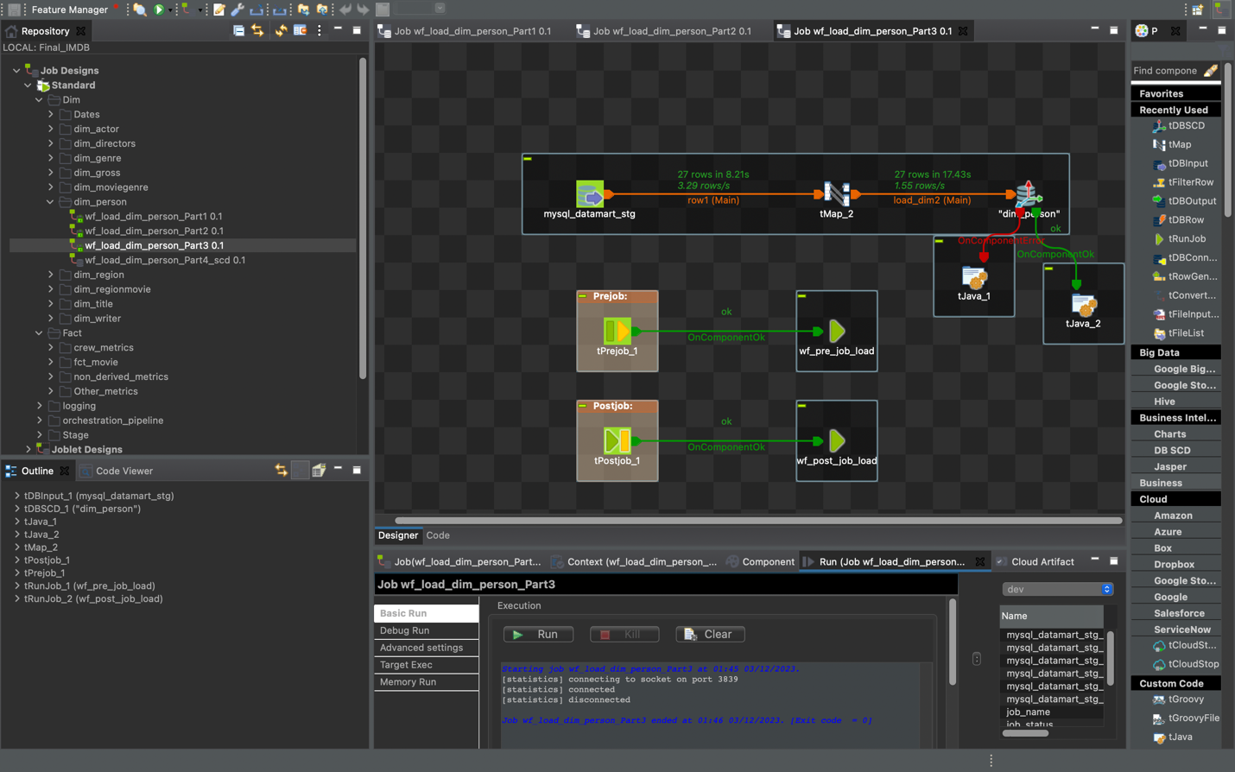

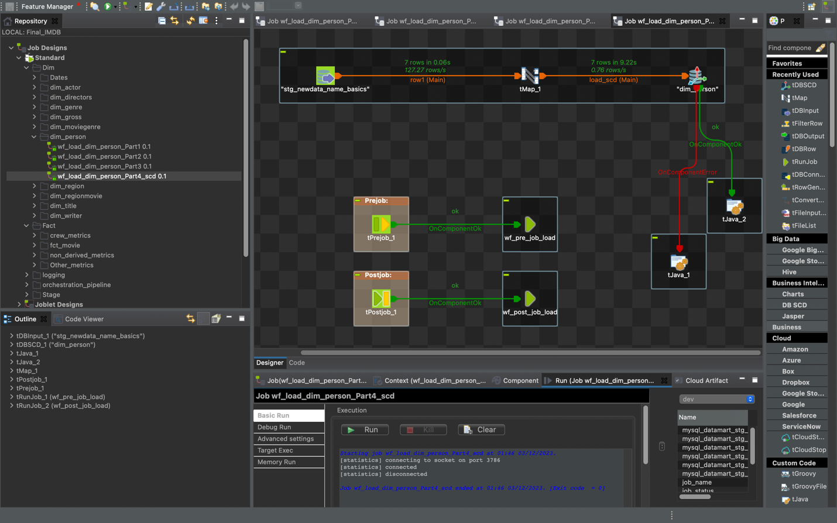

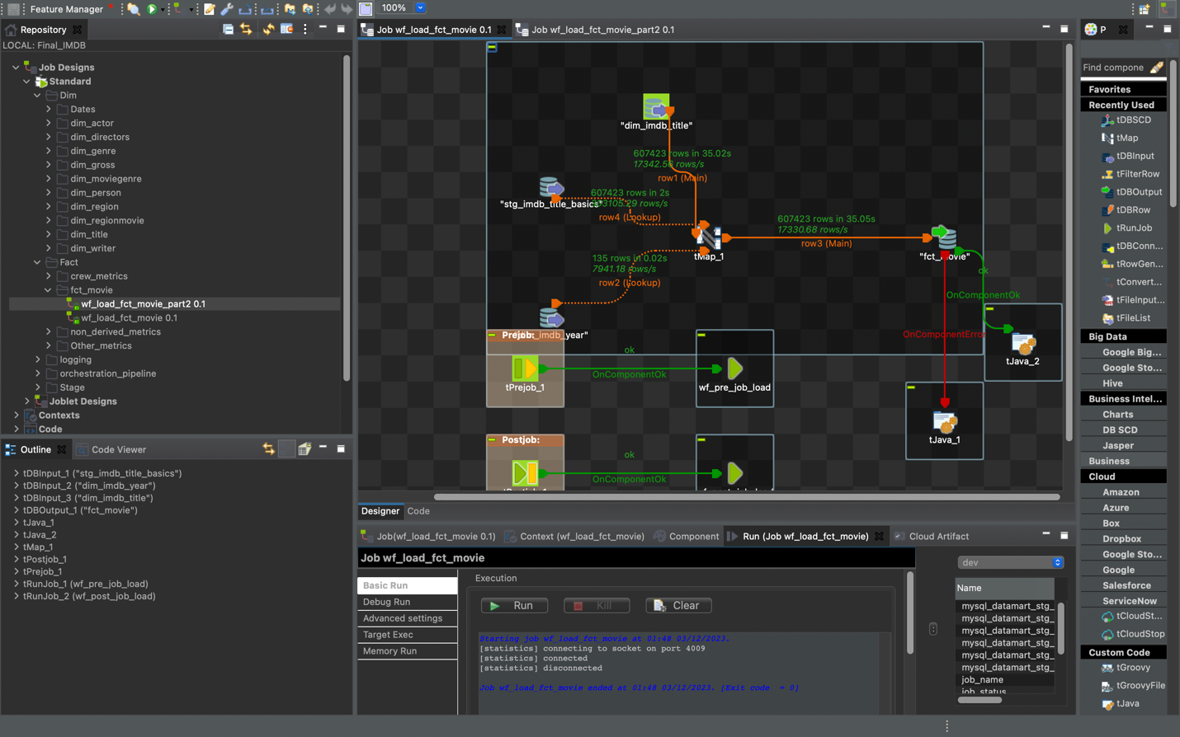

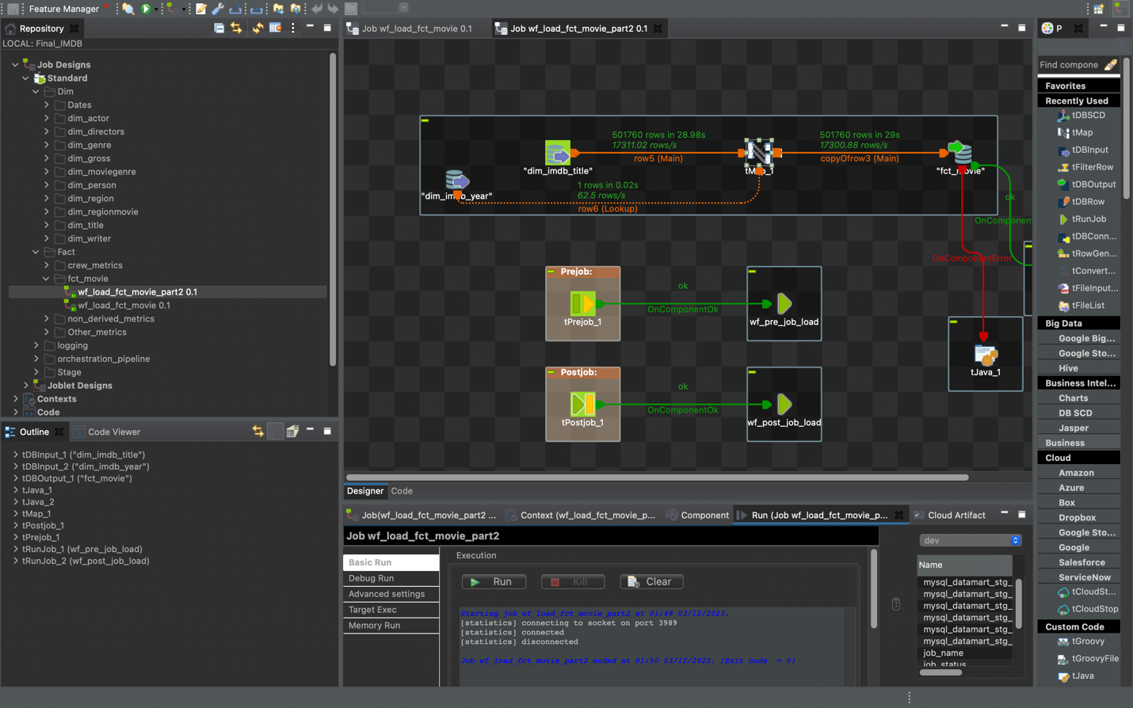

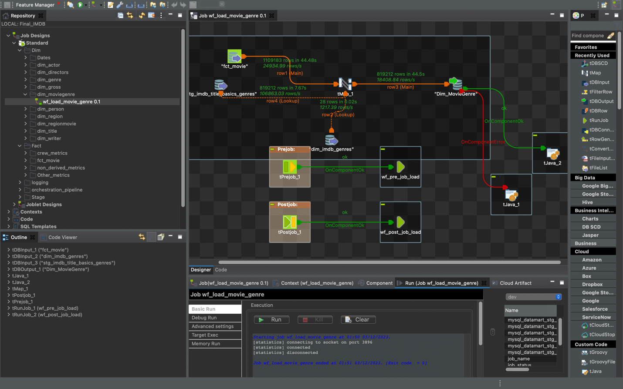

**Dim_Imdb_actor:**

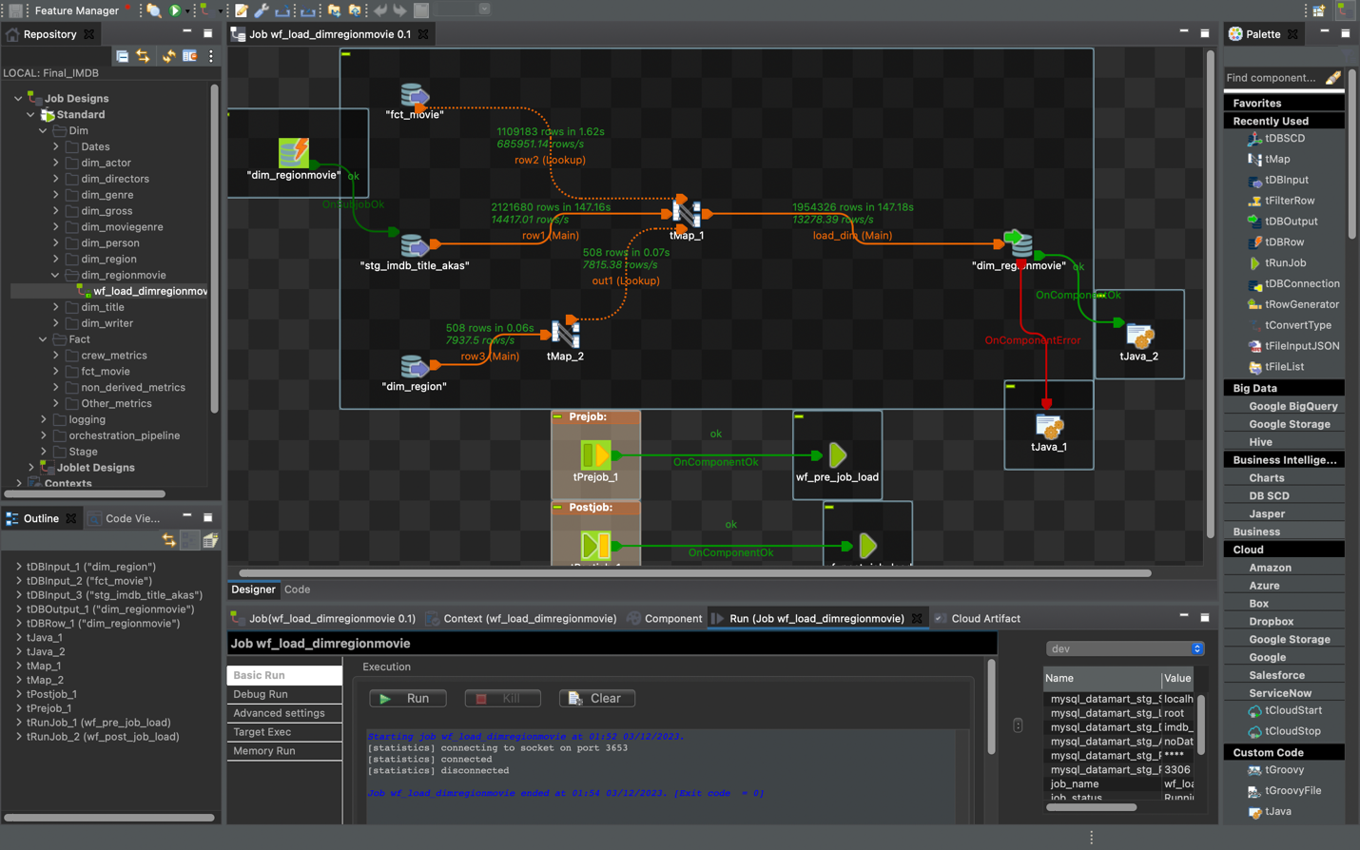

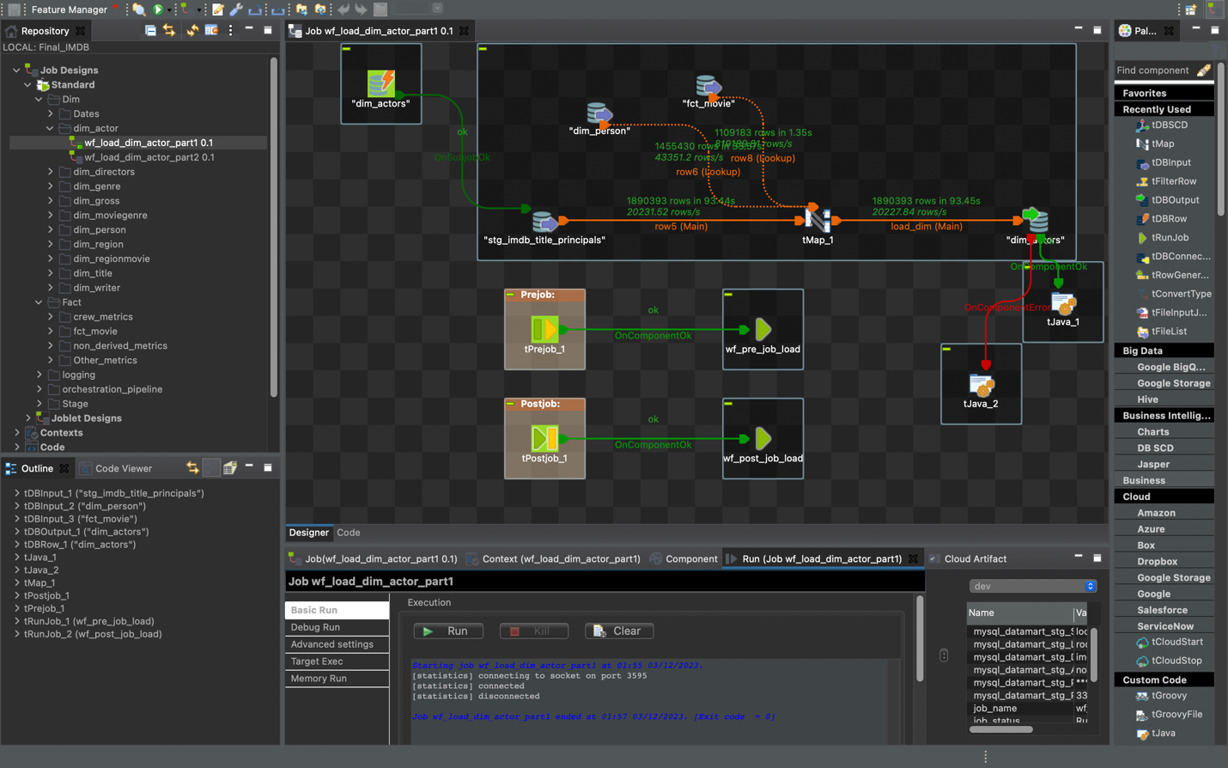

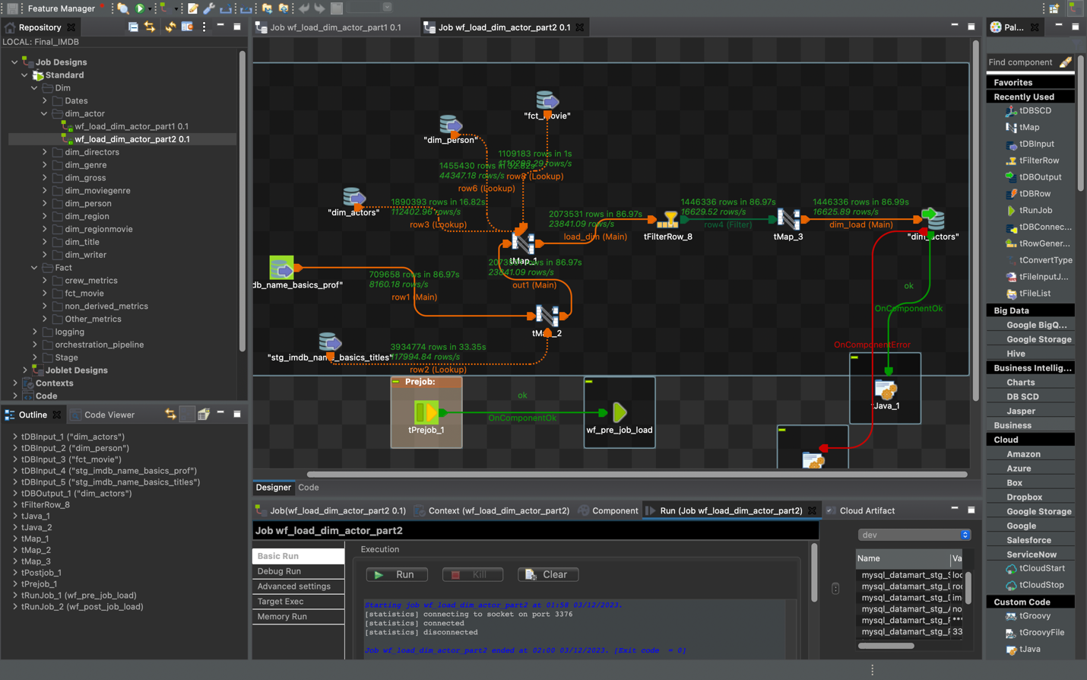

**Dim_Imdb_director :**

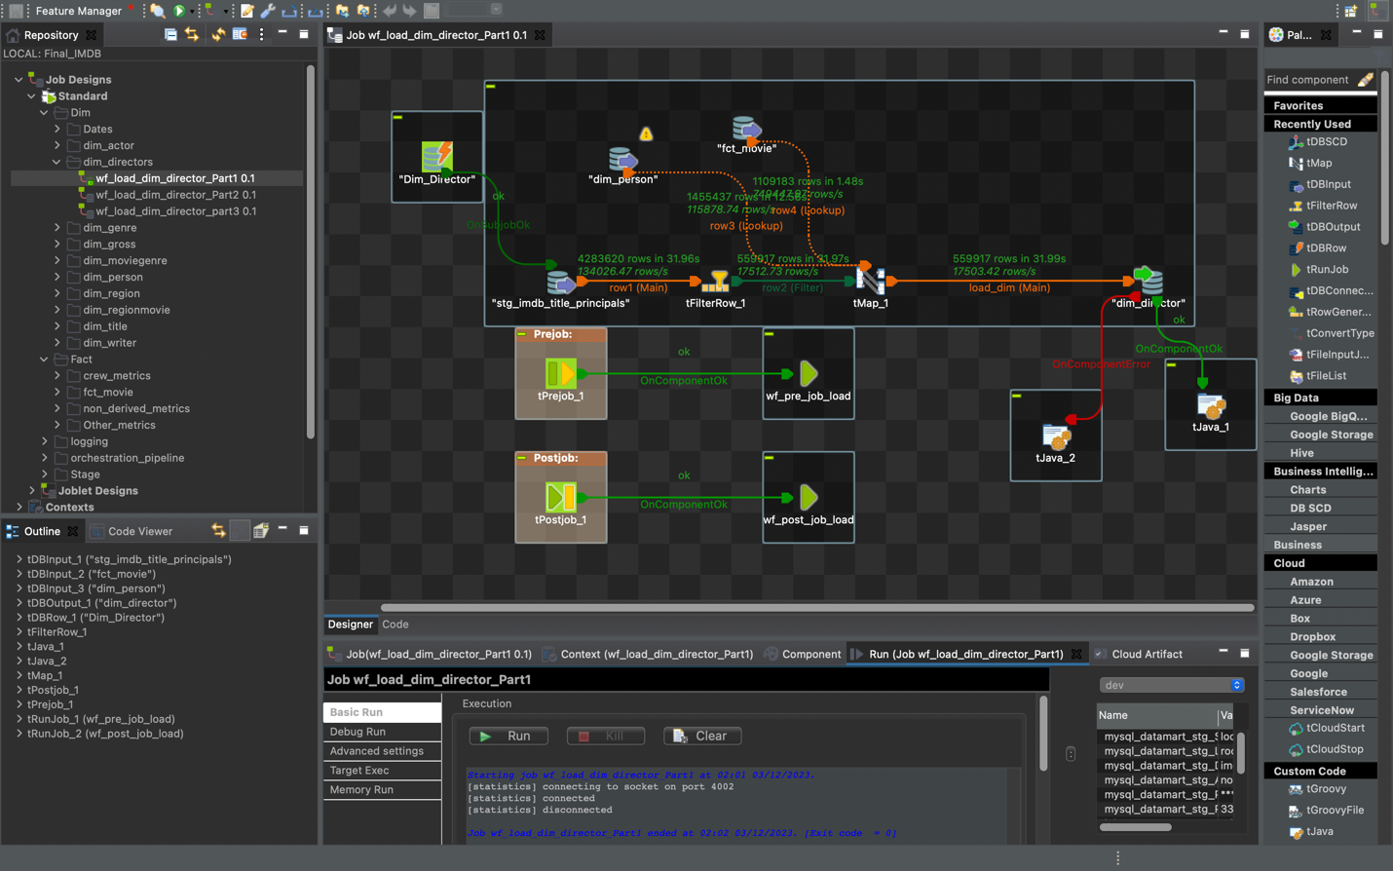

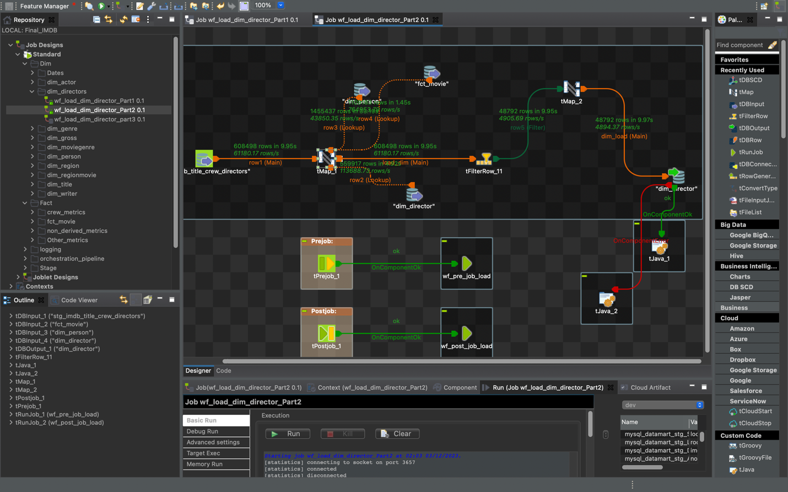

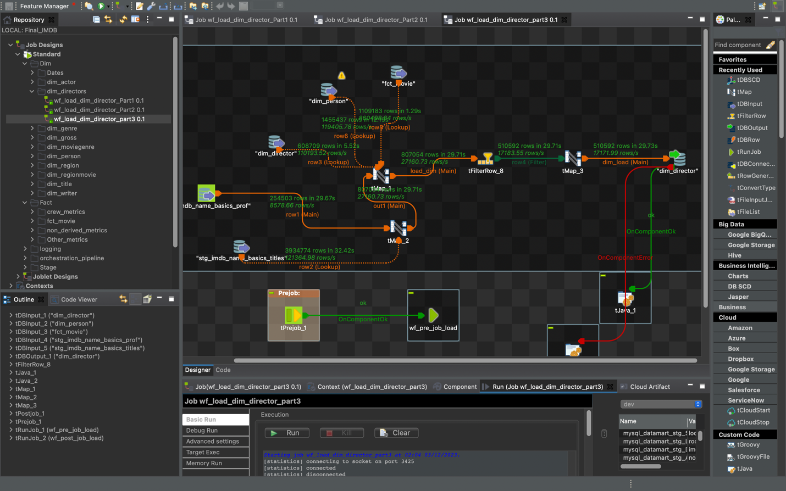

**Dim_Imdb_writer :**

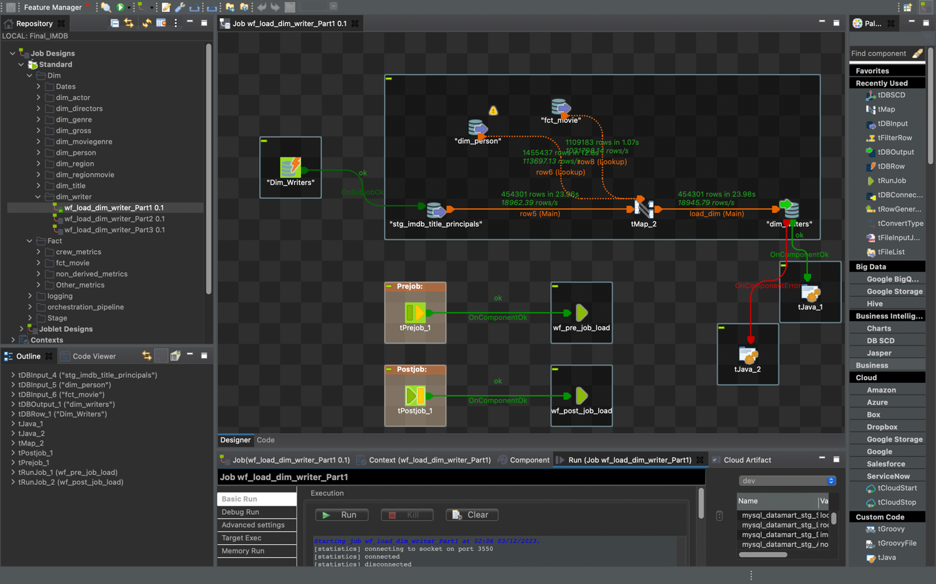

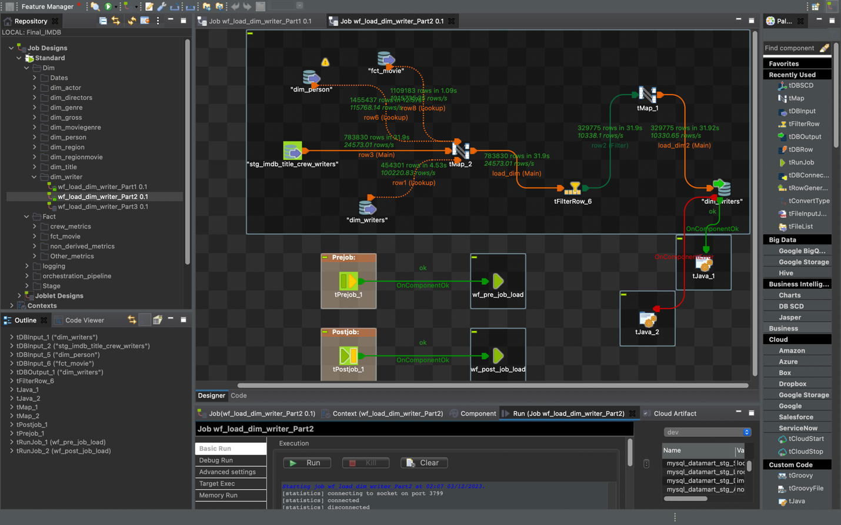

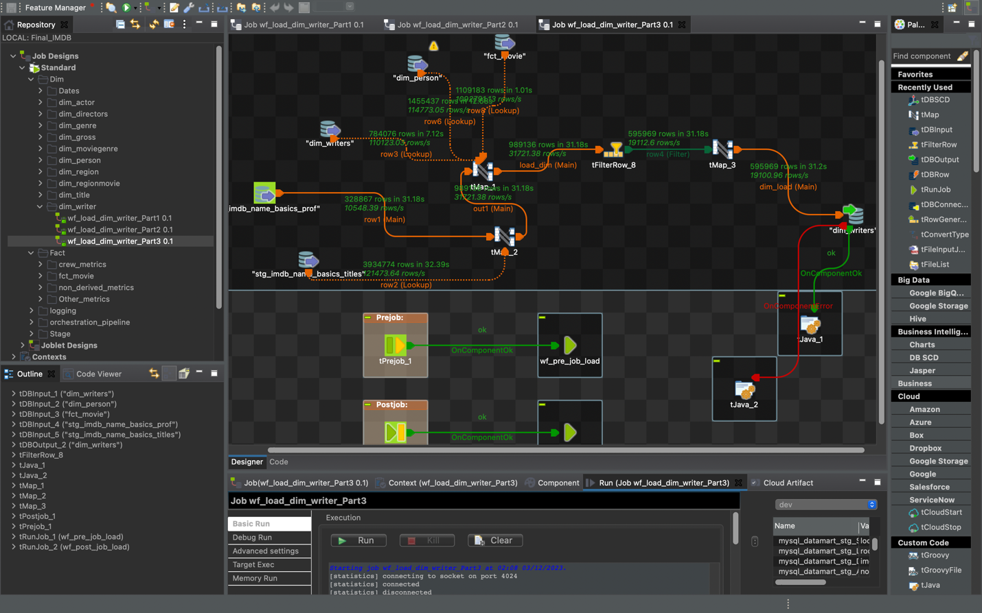

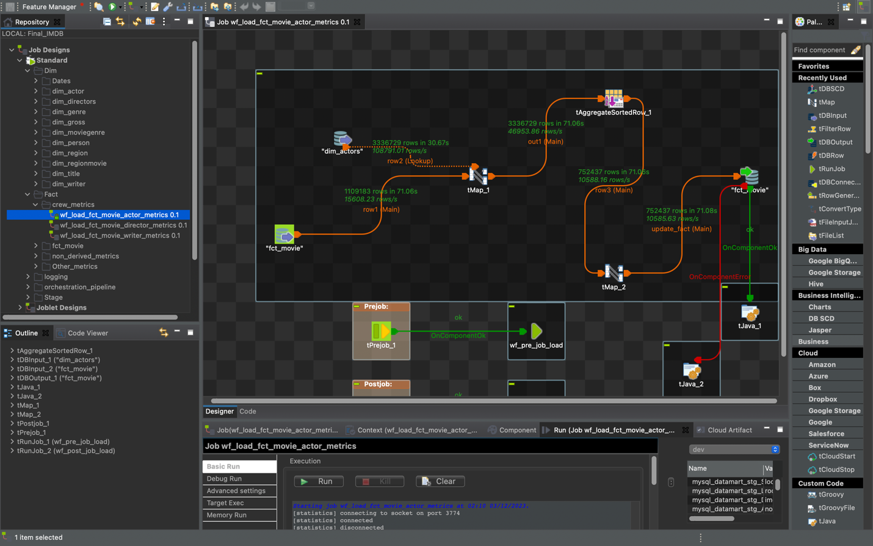

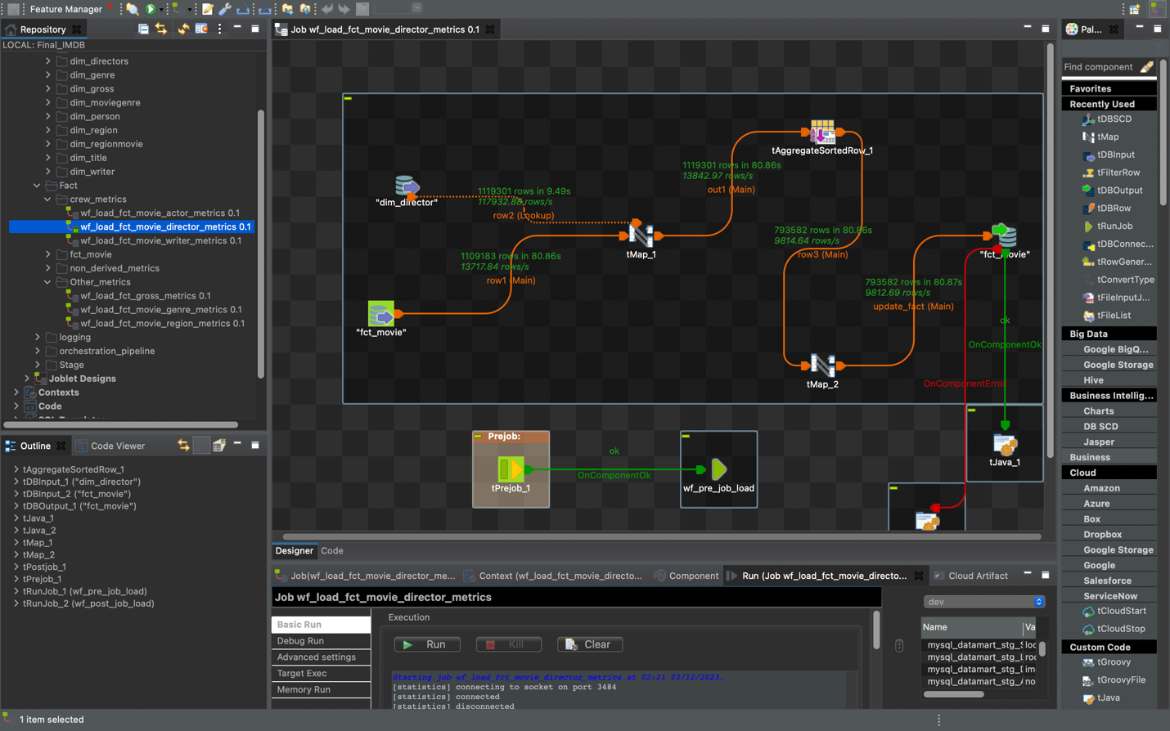

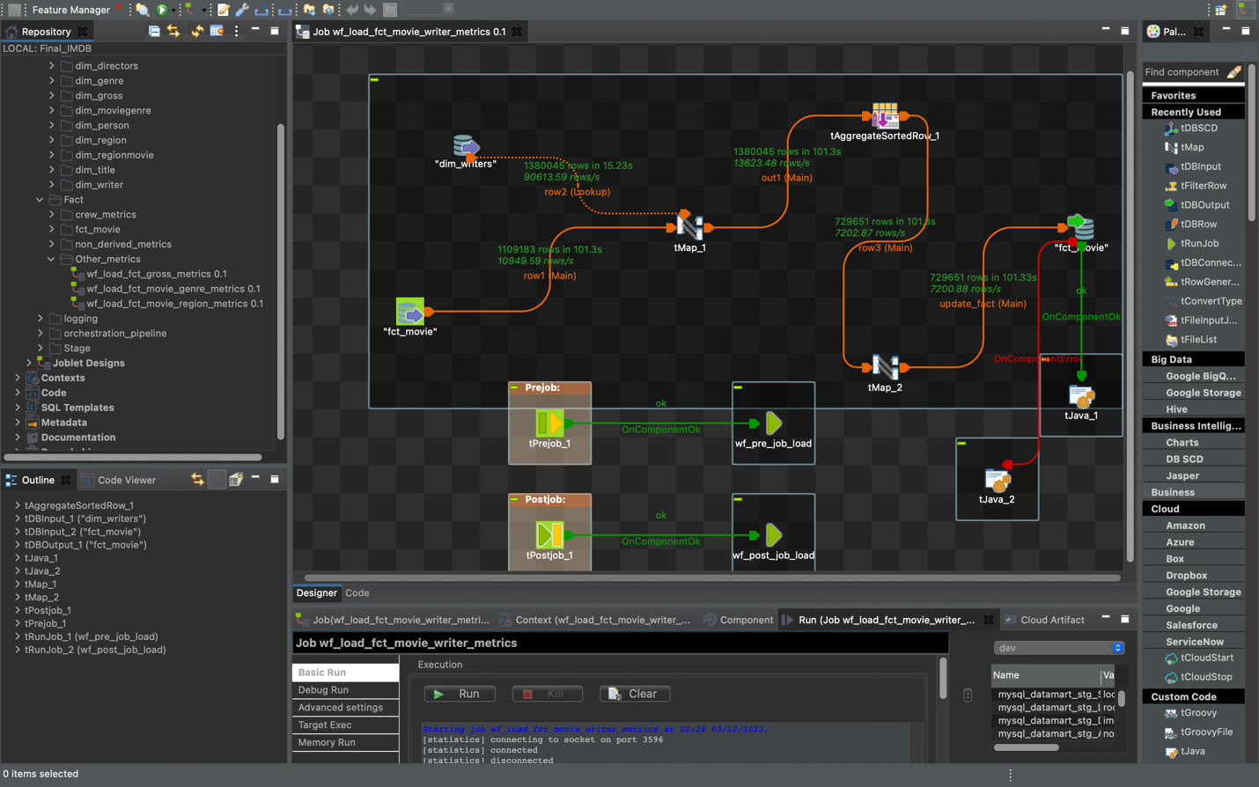

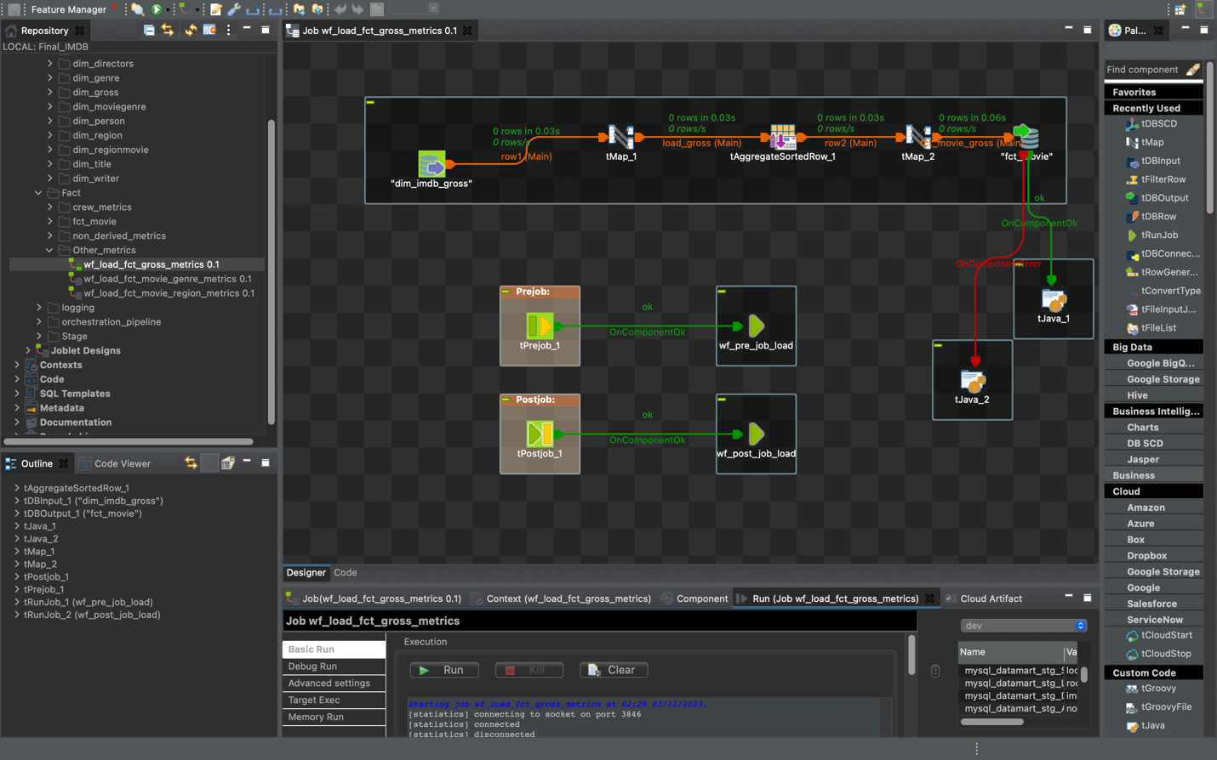

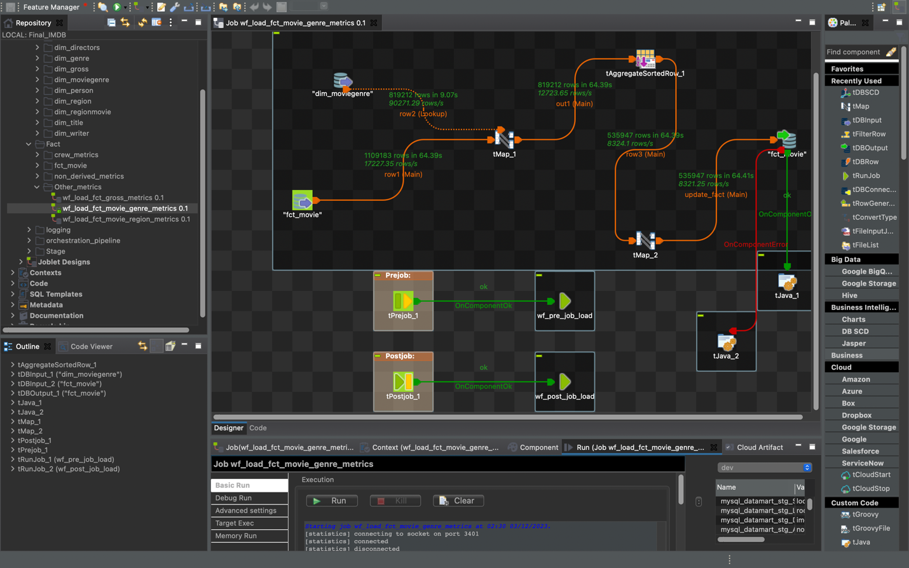

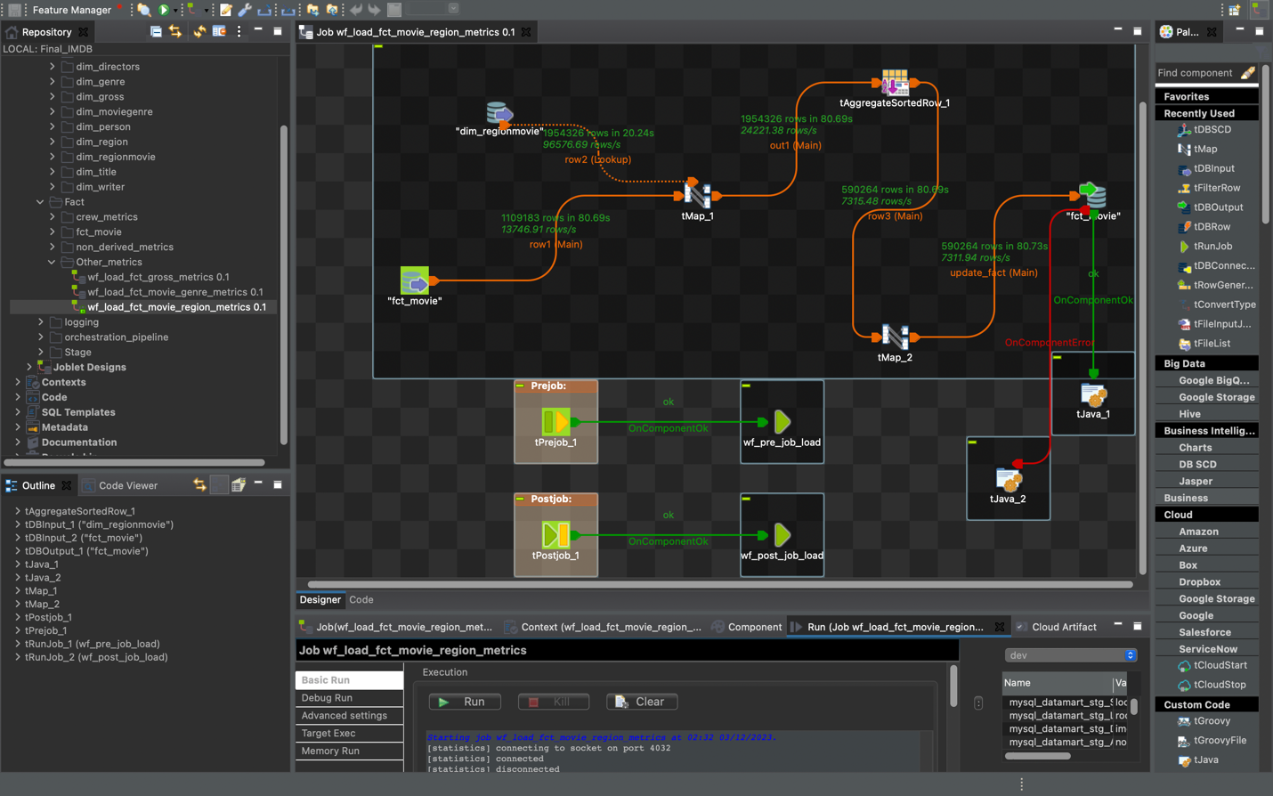

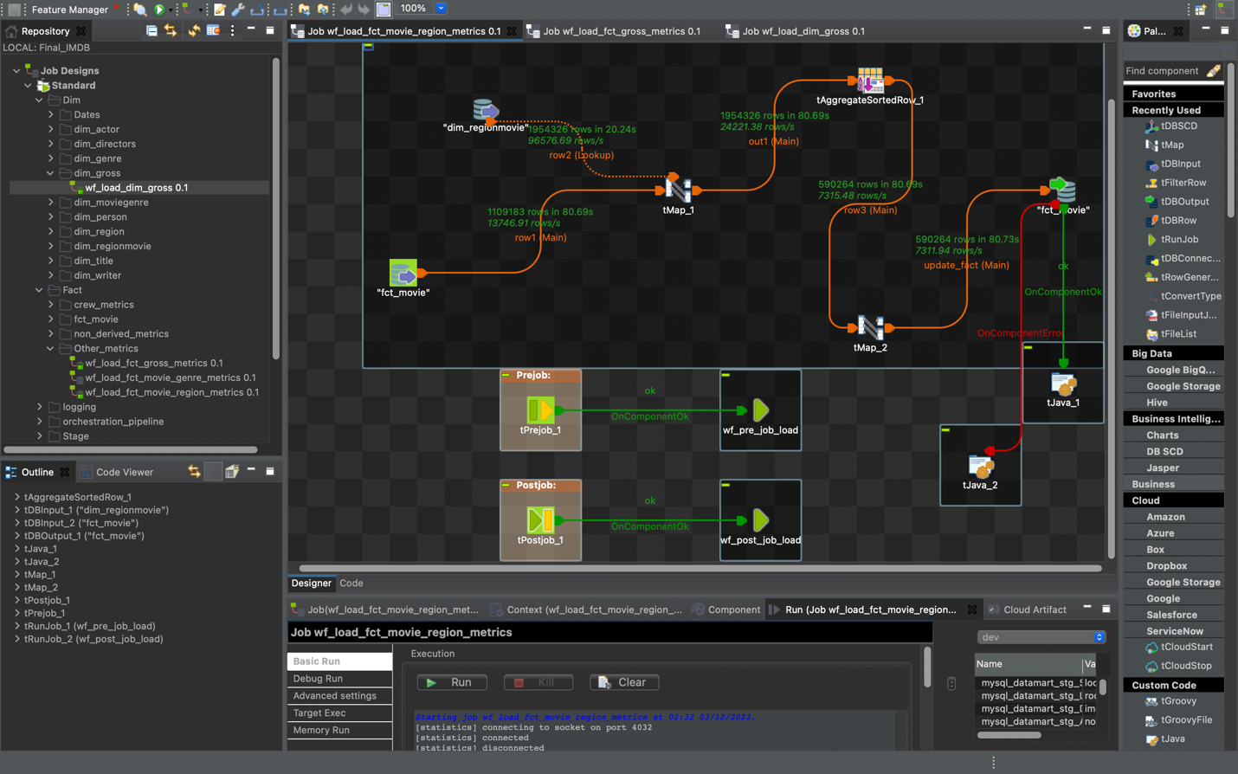

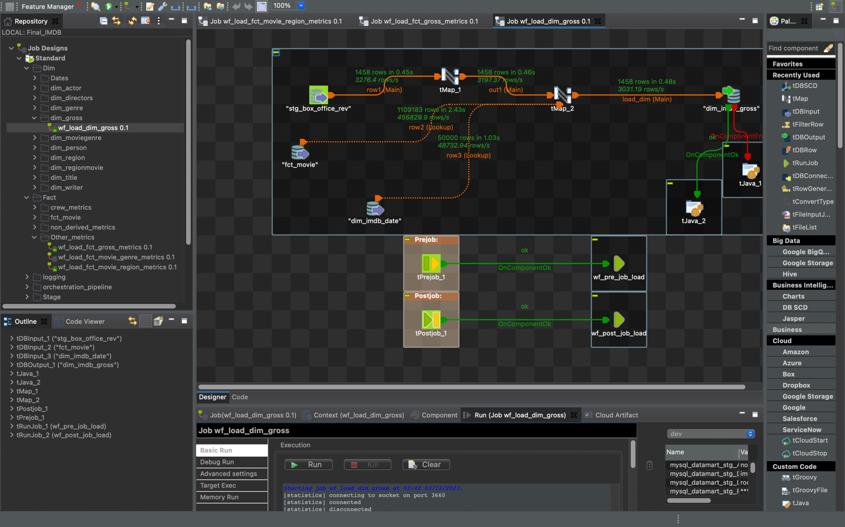

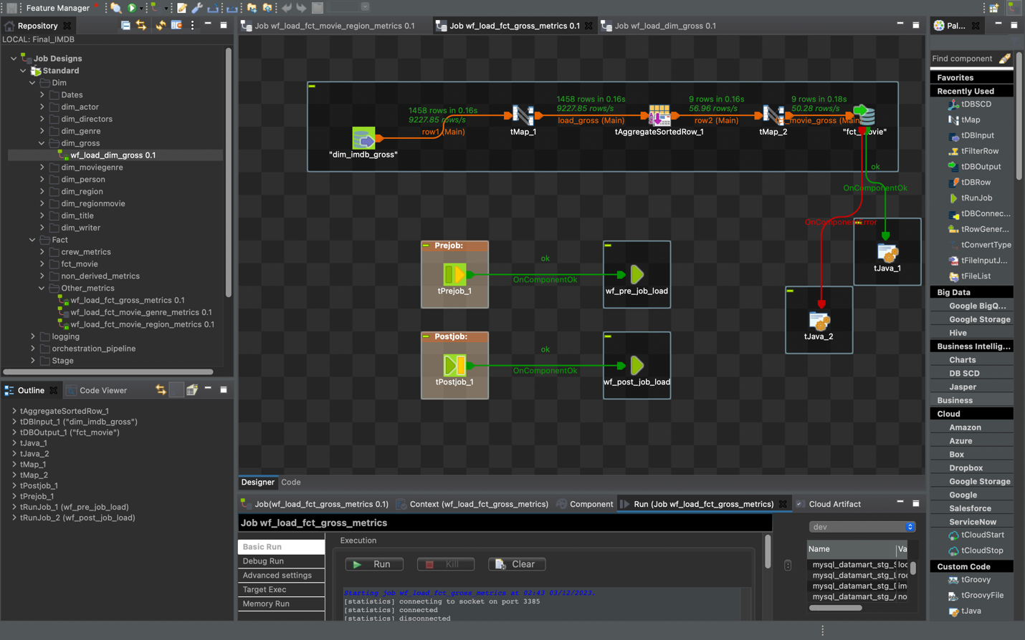

Dim_region query -

